**Module1: Introduction and Basics**

1. Display the message ‘Welcome to the PHP Training’ on the Web Page

Code editor

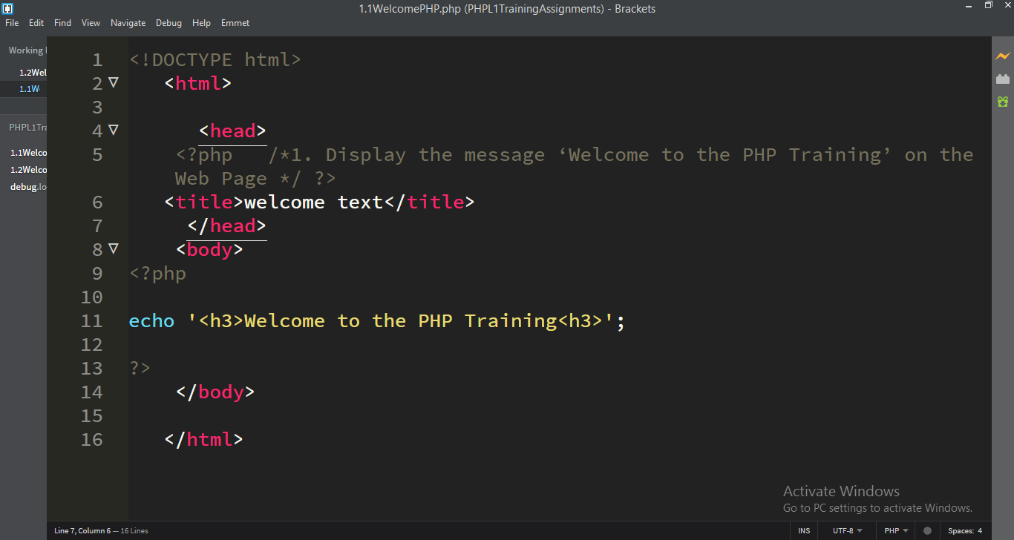Browser

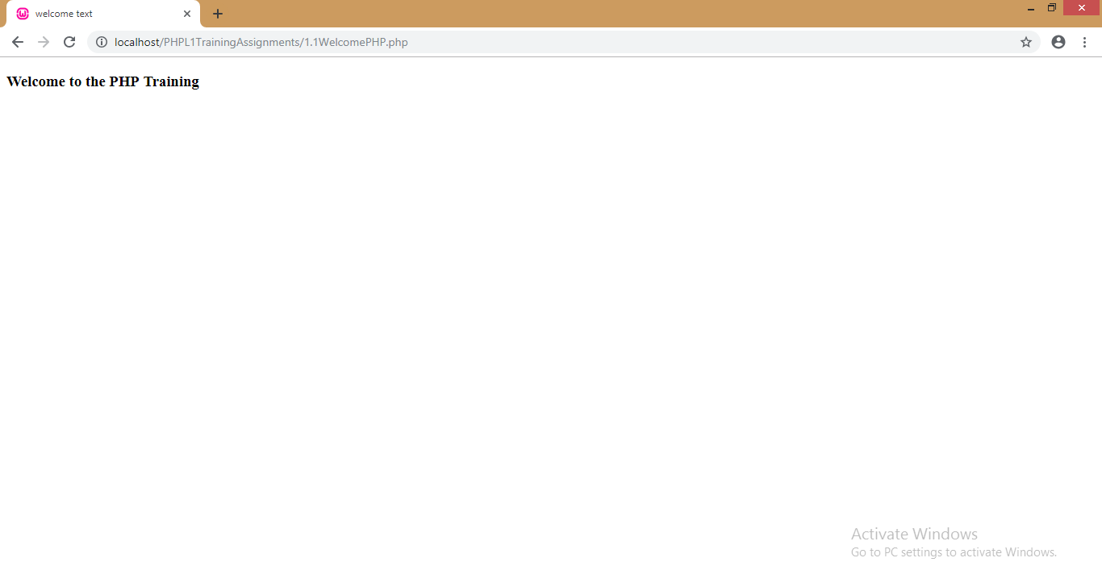2. Create two variables ‘firstName’ and ‘lastName’ and assign some sample values into it. Display a Welcome message followed by the firstName and lastName.

Code editor

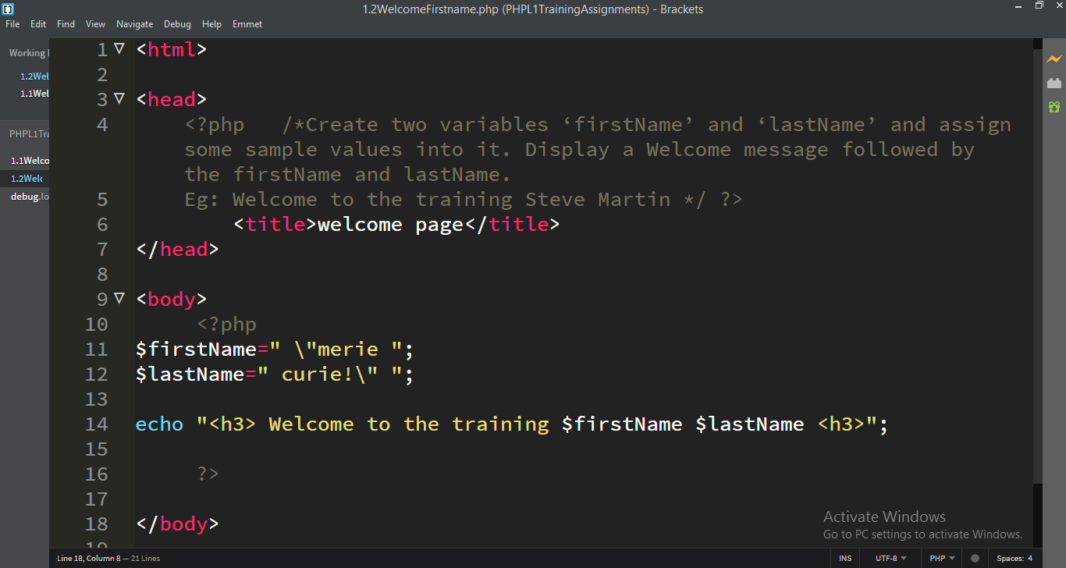

Browser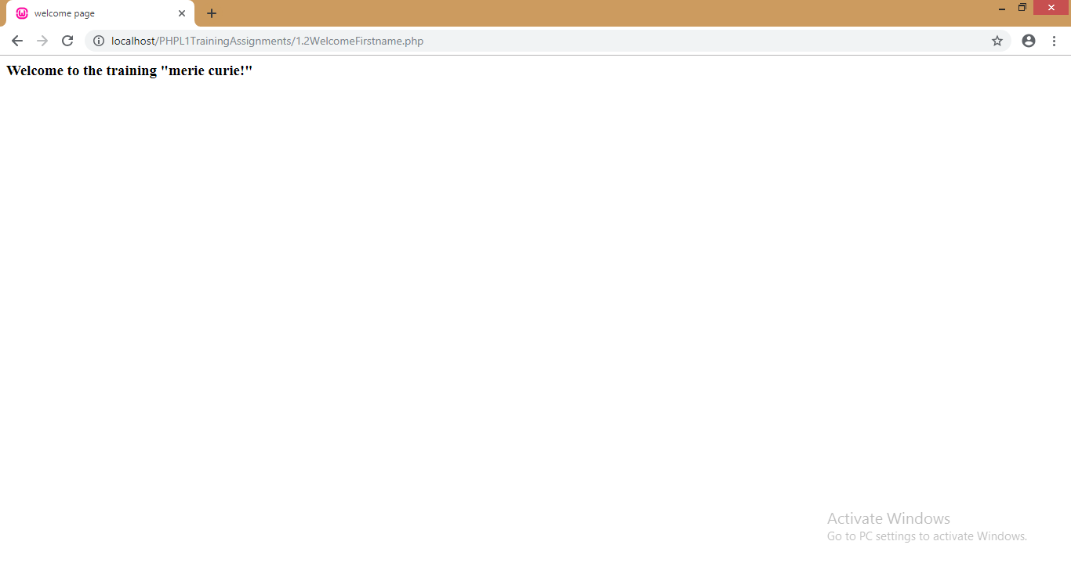

Create two constants: MINMARKS=0 and MAXMARKS=100 and display the same. Towards the end of the program, try setting /changing the value of MINMARKS=1 and then try to display it.

Code editor

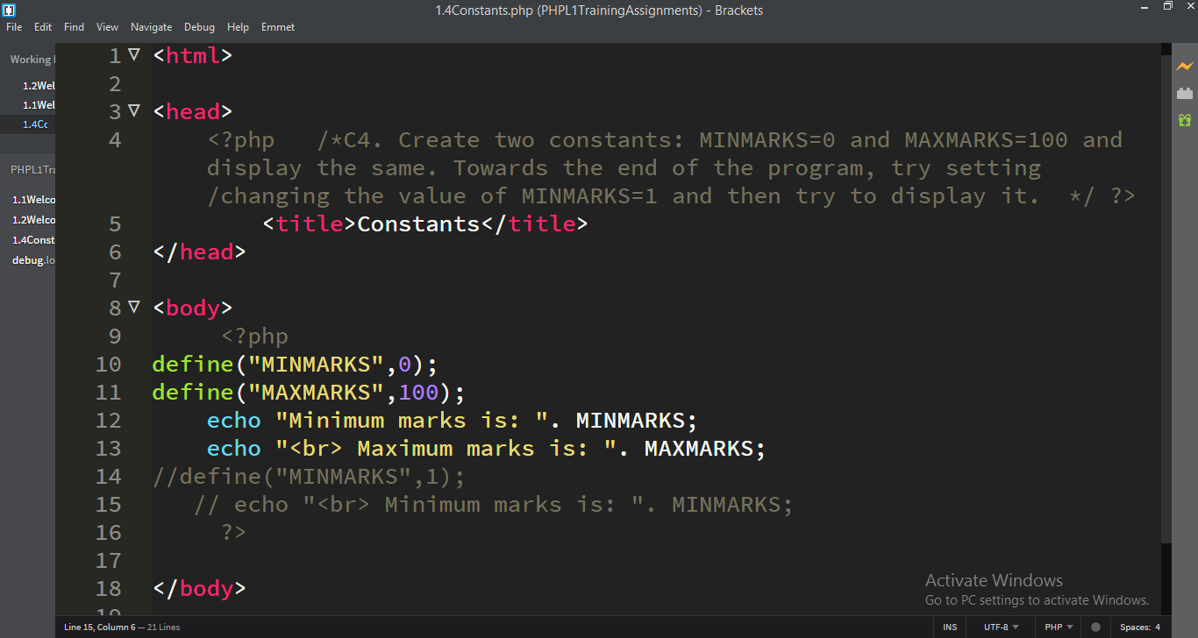

Browser

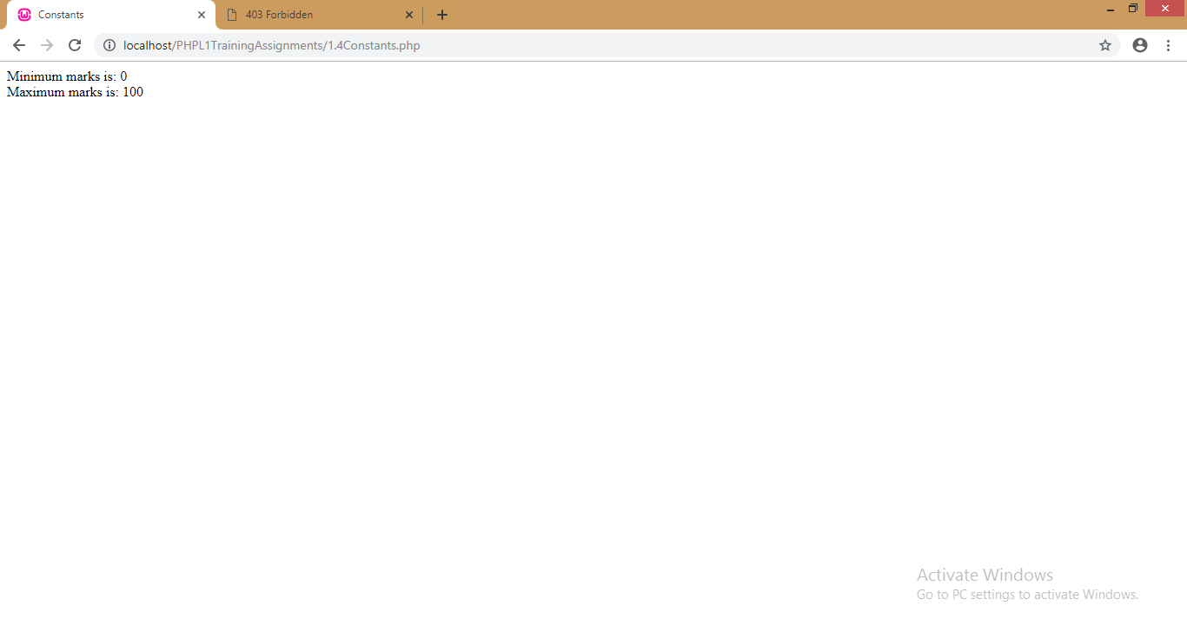

Code editor

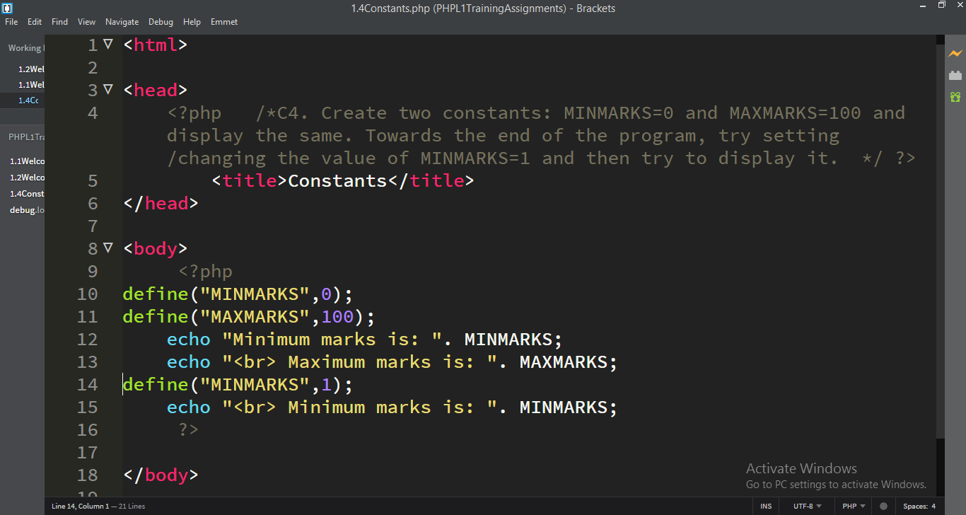

Browser

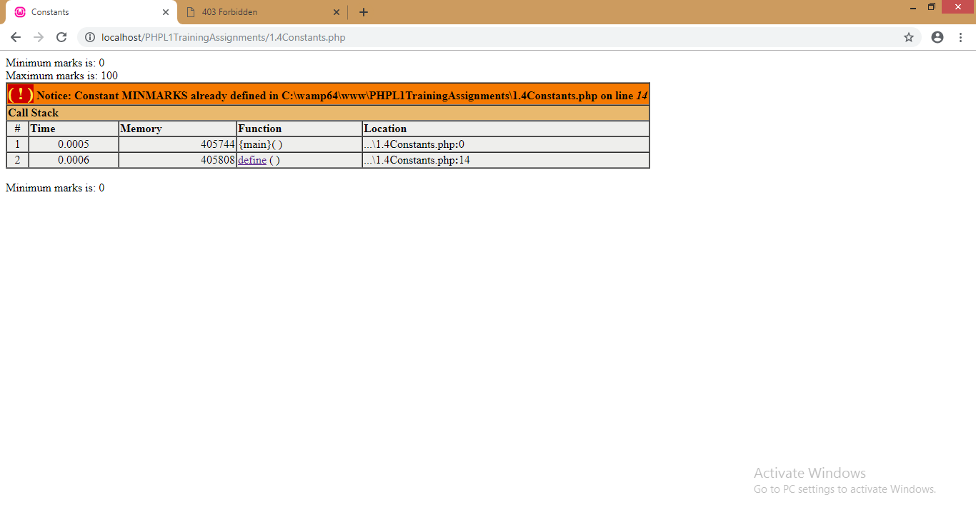

5. Have two variables ‘sciencemarks’ and ‘mathsmarks’ and assign some sample marks (number) onto it. If sciencemarks is greater than mathsmarks, display the message ‘Science is highest’ else ‘Maths is highest’. Do it using the **ternary** operator.

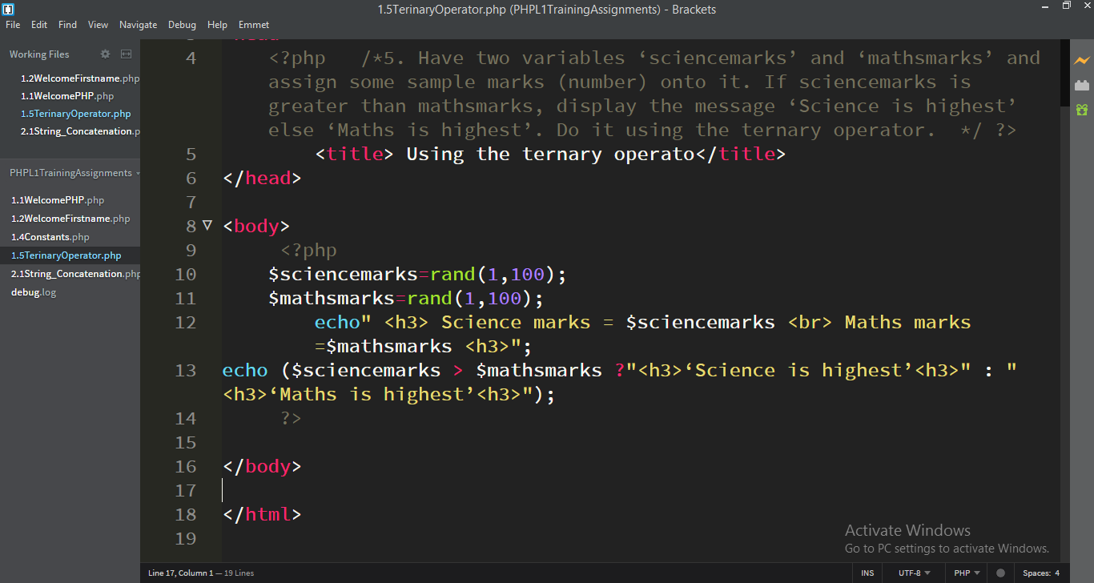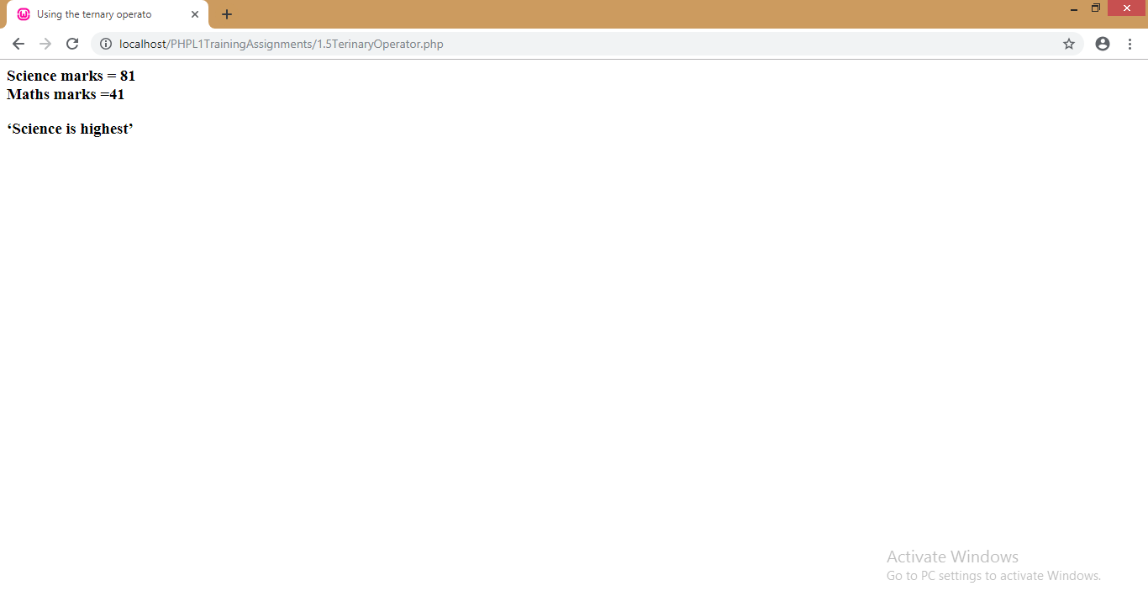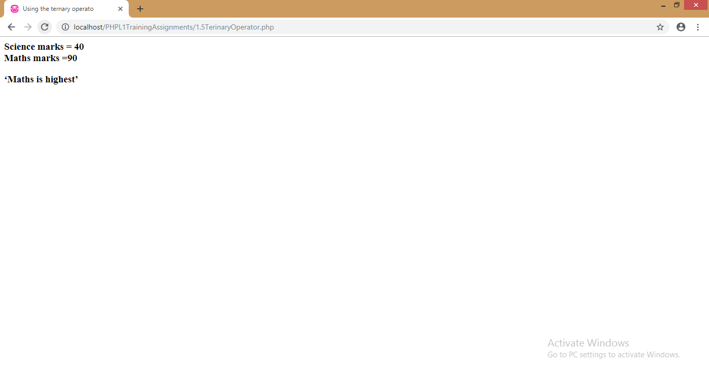

**Module2: PHP Strings**

**1.** Have three variables ‘Name’ that contains the name of the student, ‘Semester’ that contains the semester number that the student is in and ‘Marks’ that contains his/her marks. Now display the output which looks like “<Name> of <Semester> Semester has scored <Marks> in his/her exams’. (Eg: Roger of 3 semester has scored 88 in his/her exams)

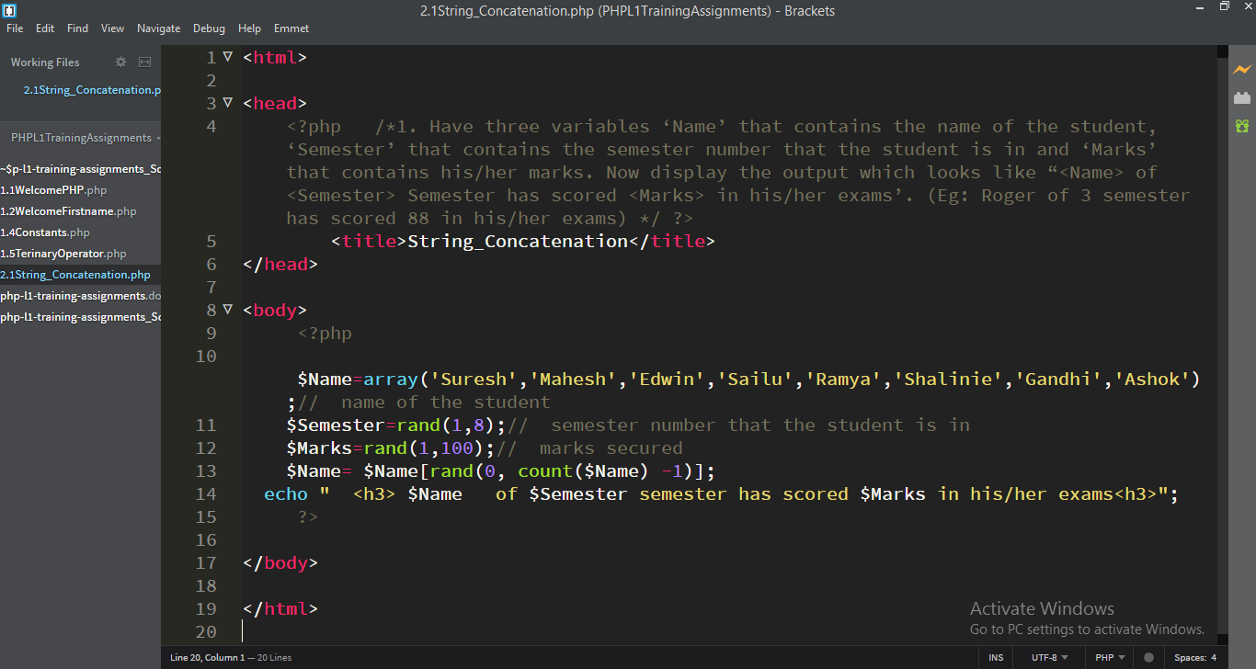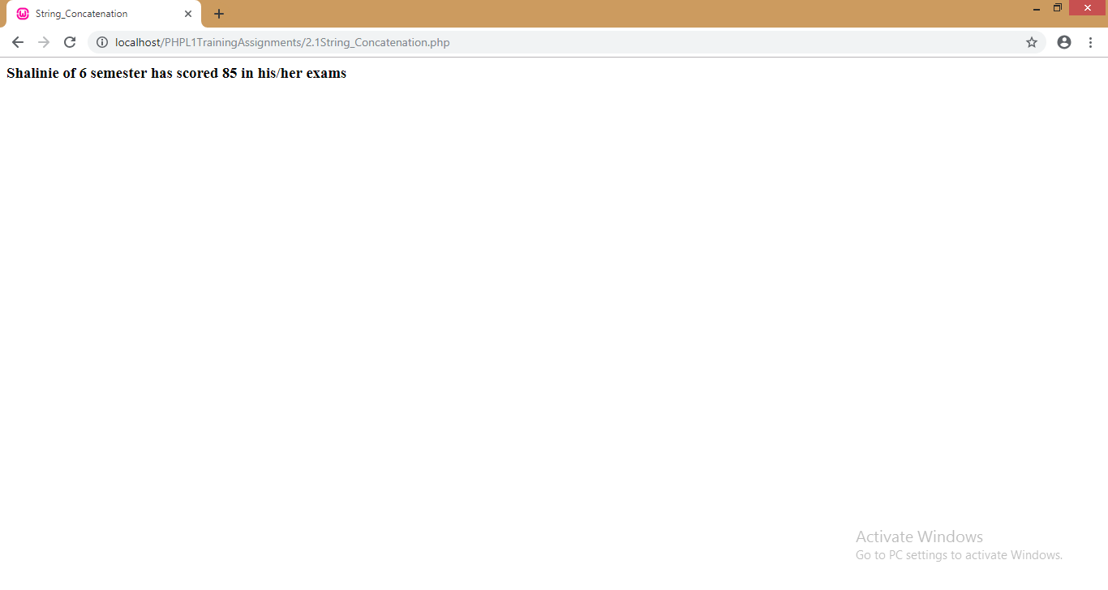

2. Check whether String interpolation happens within “ “ (double quotes) and ‘ ‘ (single quotes) 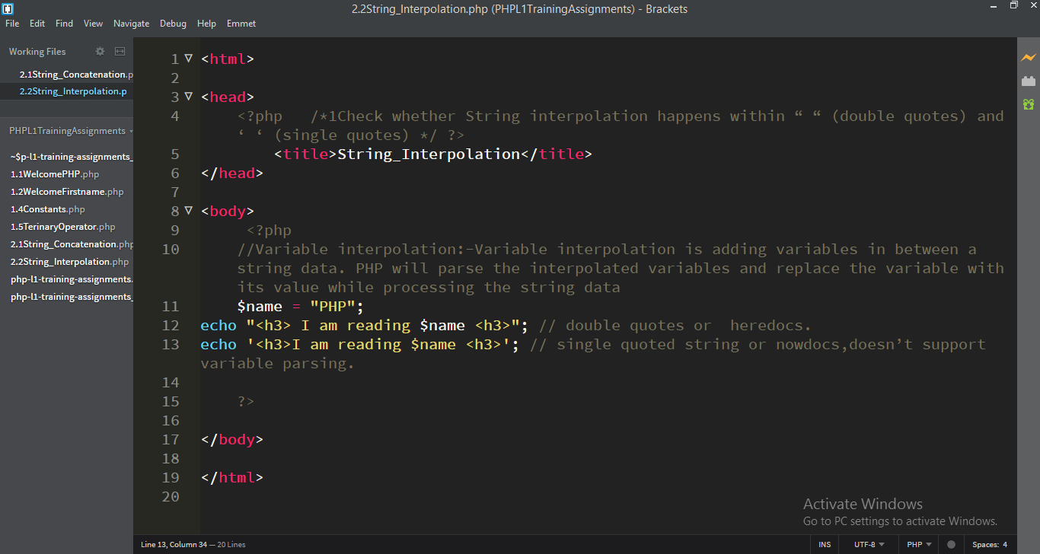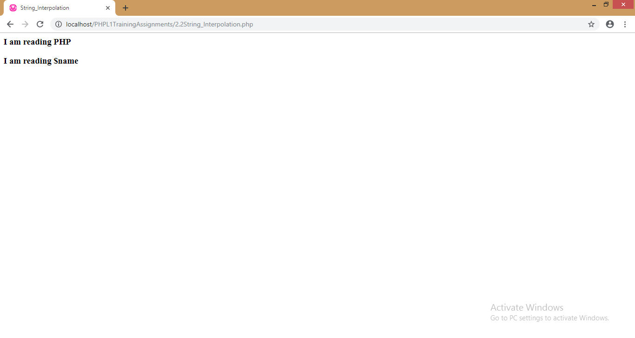3. Try to display the output -- Sachin’s 100th century within double quotes and within single quotes.

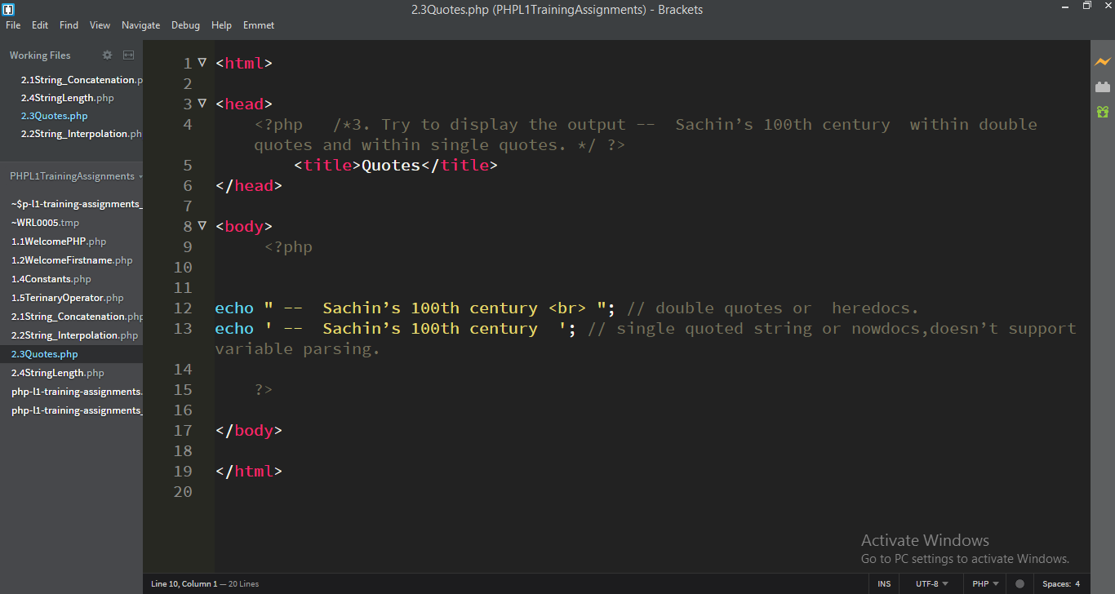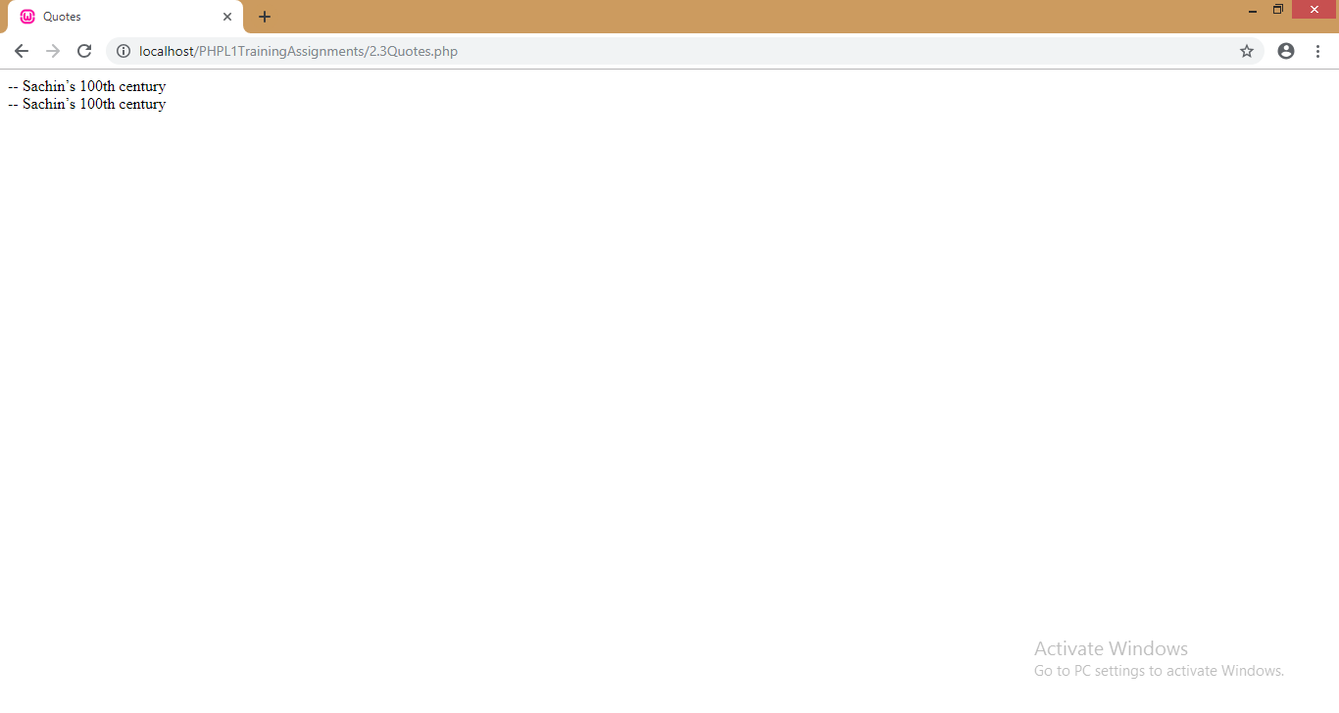

4. A variable ‘company’ has value ‘Wipro Limited’ in it. Find the length of string and display.

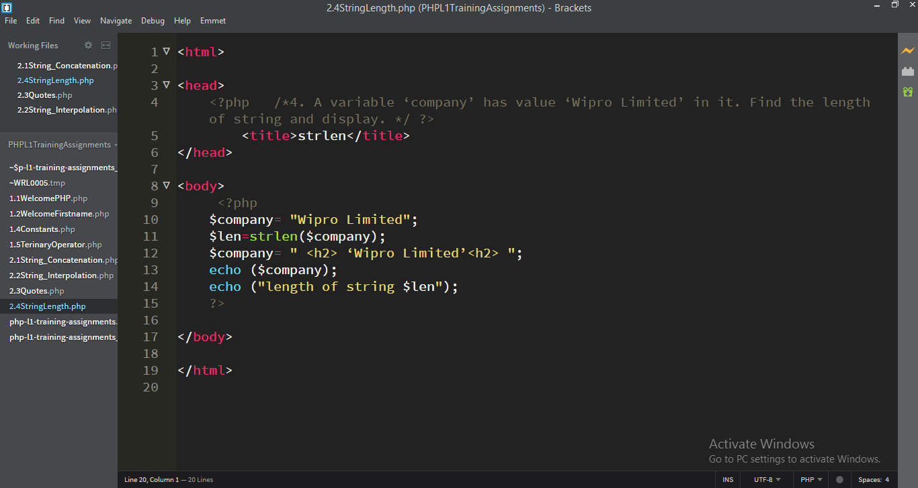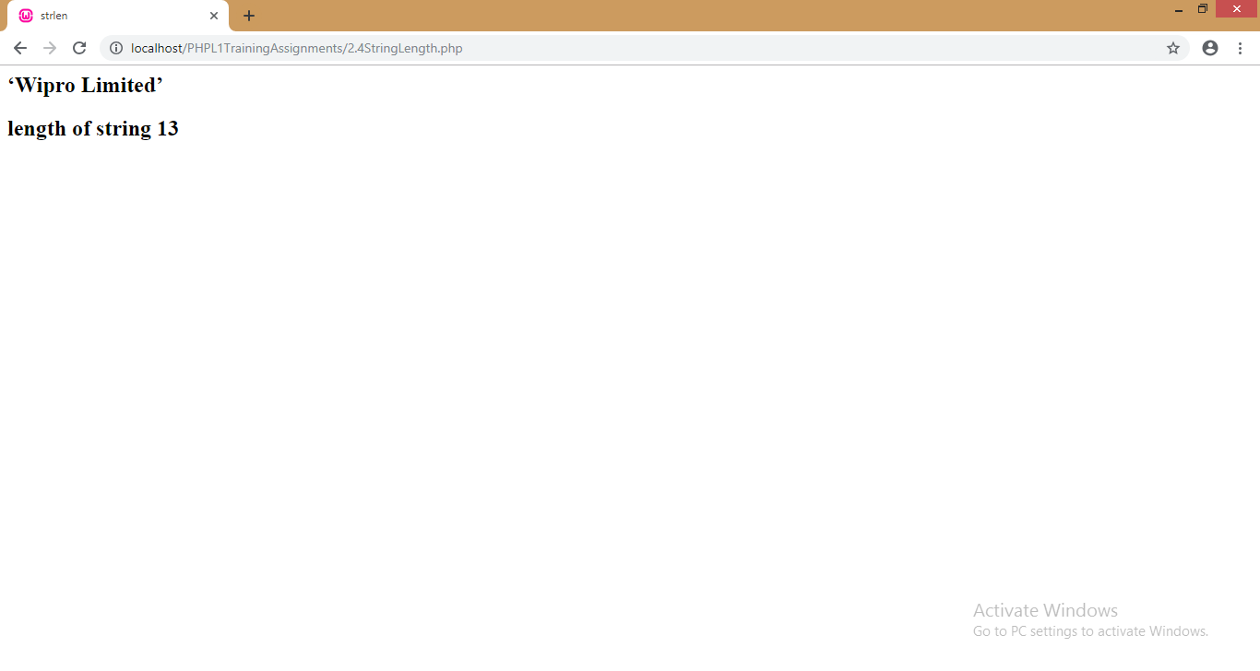5. A variable ‘fullname’ contains the employee’s full name with extra unnecessary spaces before the name and after the name. Remove the unnecessary spaces before and after the name and display it.

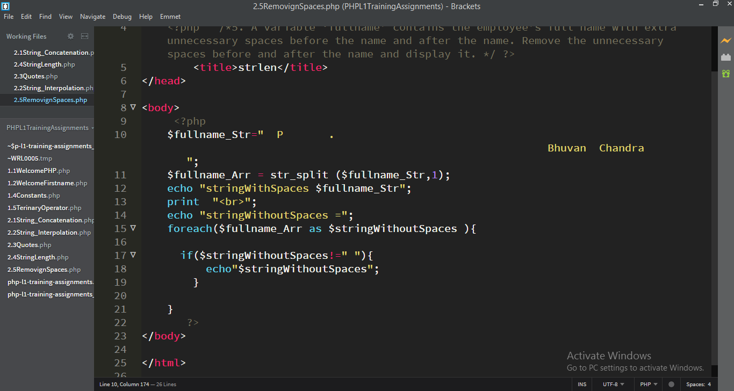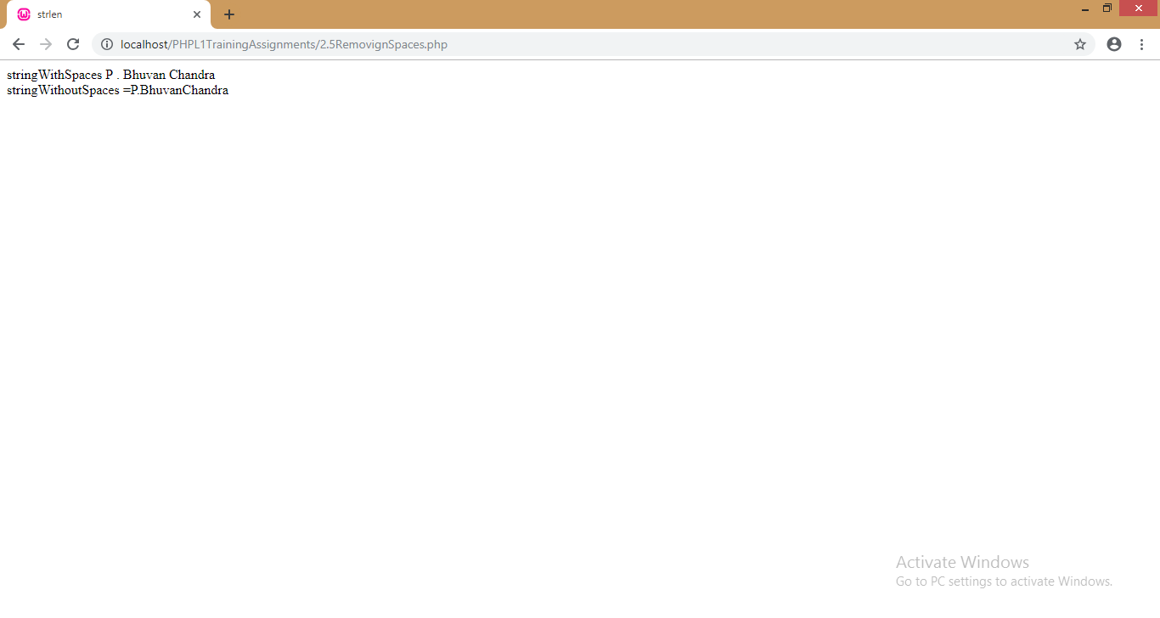 6. A variable called ‘name’ contains the value “Roger”. Convert it into lowercase. Another variable ‘city’ contains the value ‘Bangalore’ in it. Convert it into Uppercase. Print both variables.

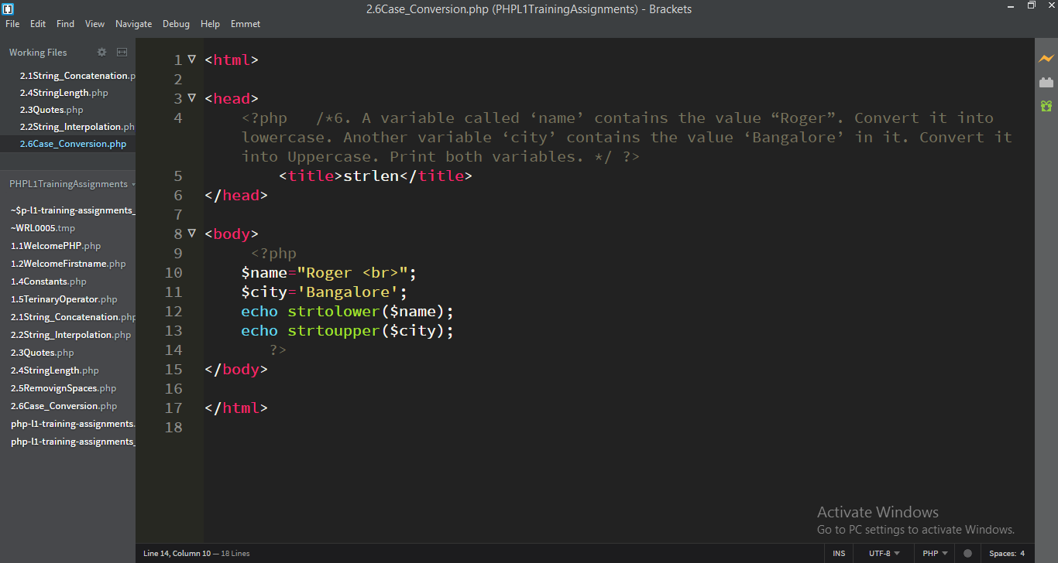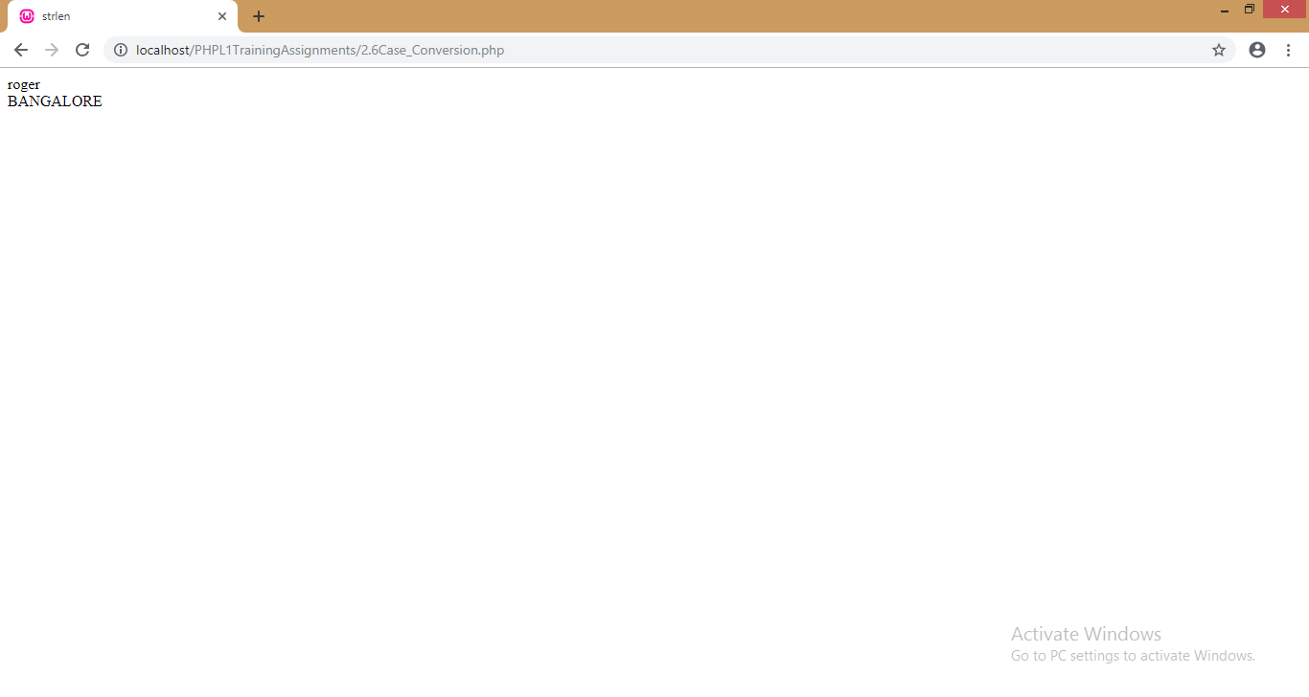7. A string variable contains the values “**Ask not what your nation has done for you. Ask what you can do for your nation**”. Find for the occurrence of the substring ‘nation’ in it and replace with ‘country’. Also find out how many (count of) replacements were made. 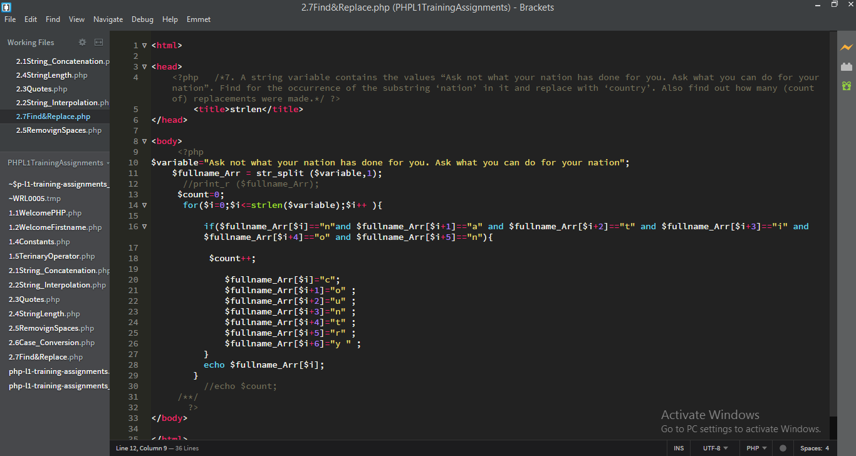 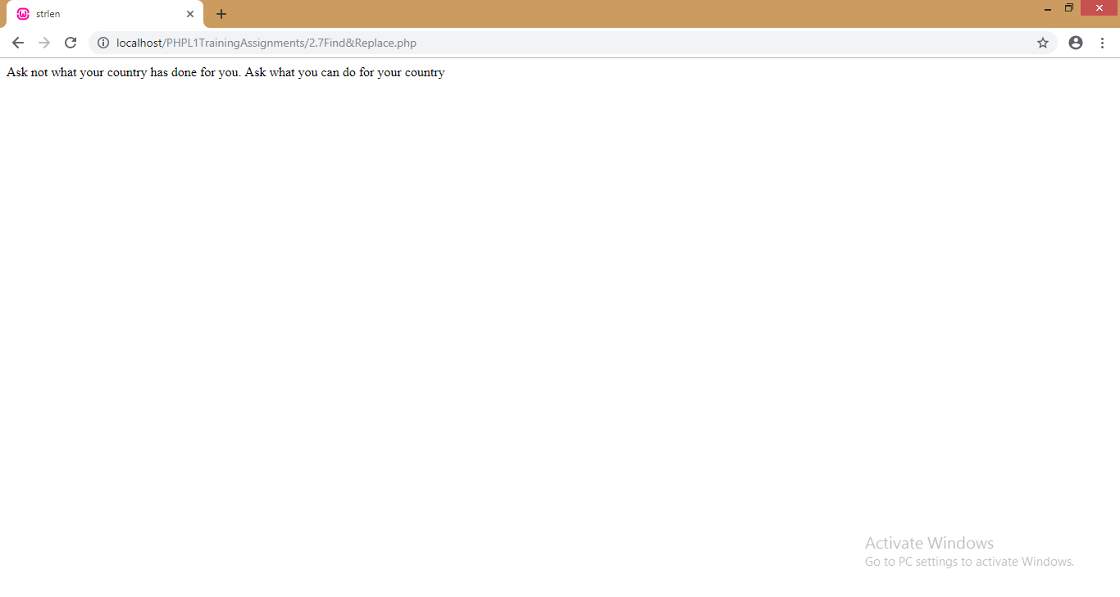

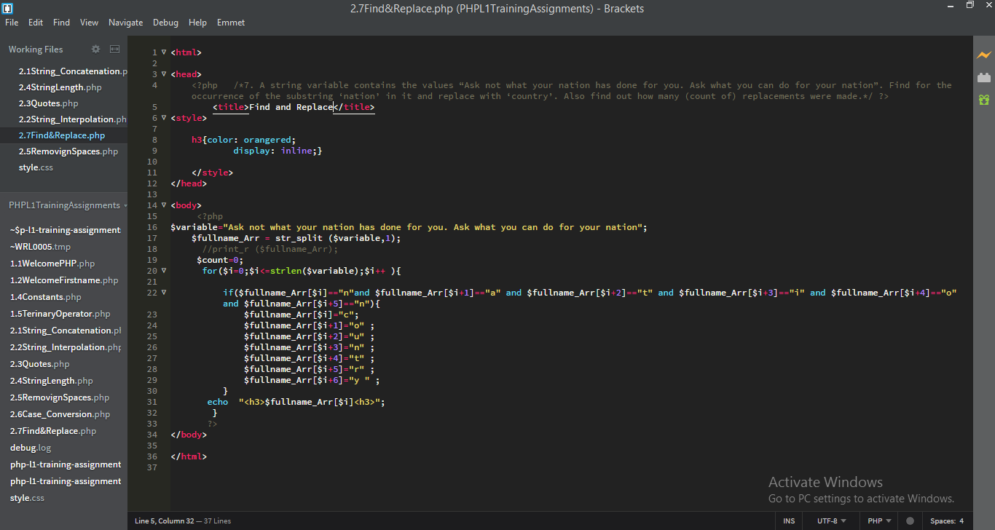 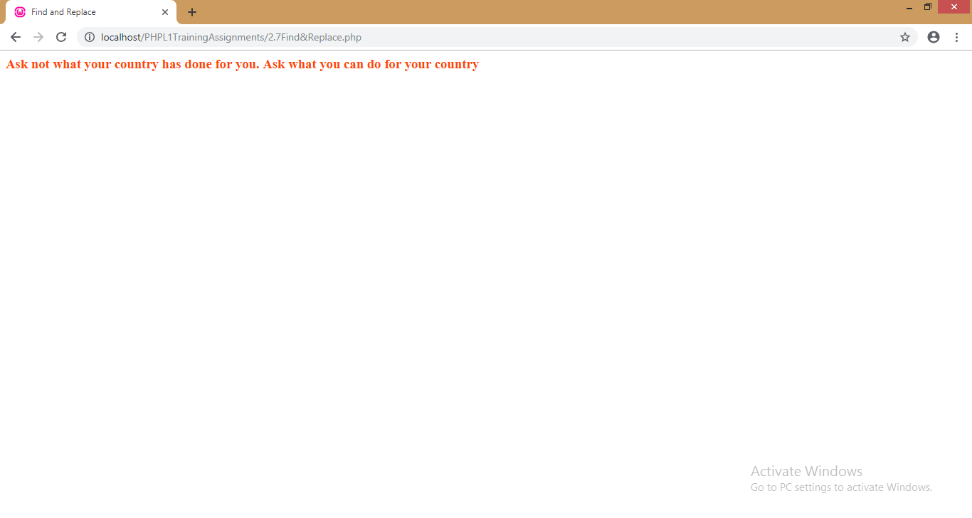 **Module3: PHP Arrays**

1. Create an array of 5 country names and its capital and display all. Also display the capital of only one selected country

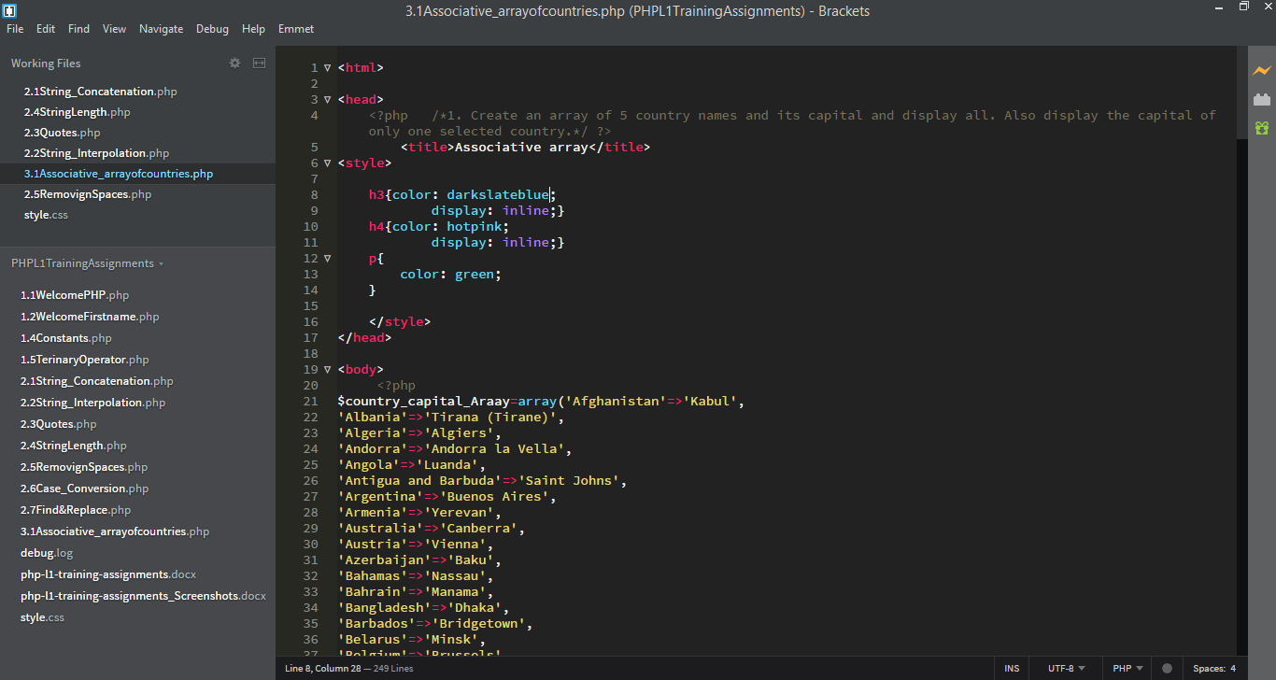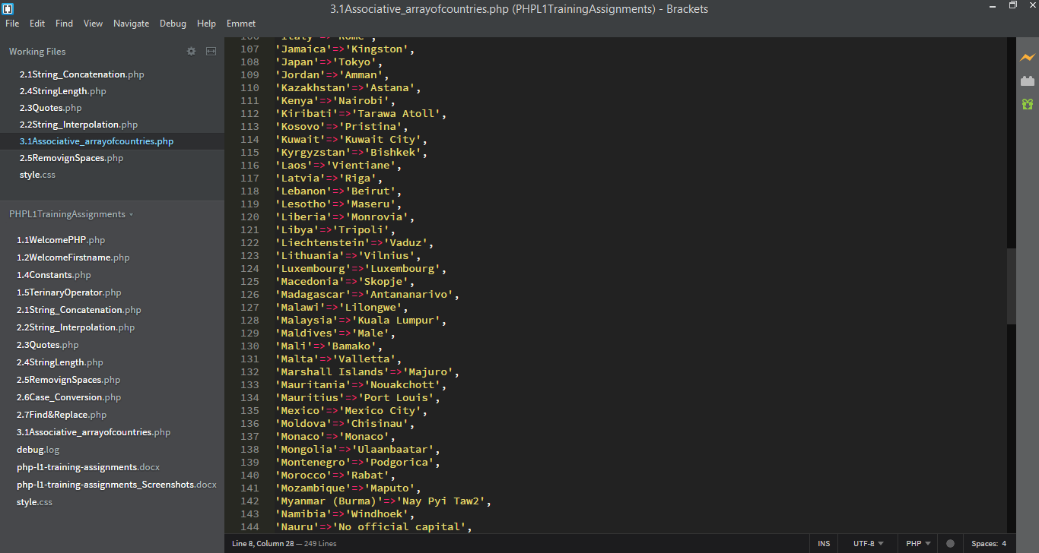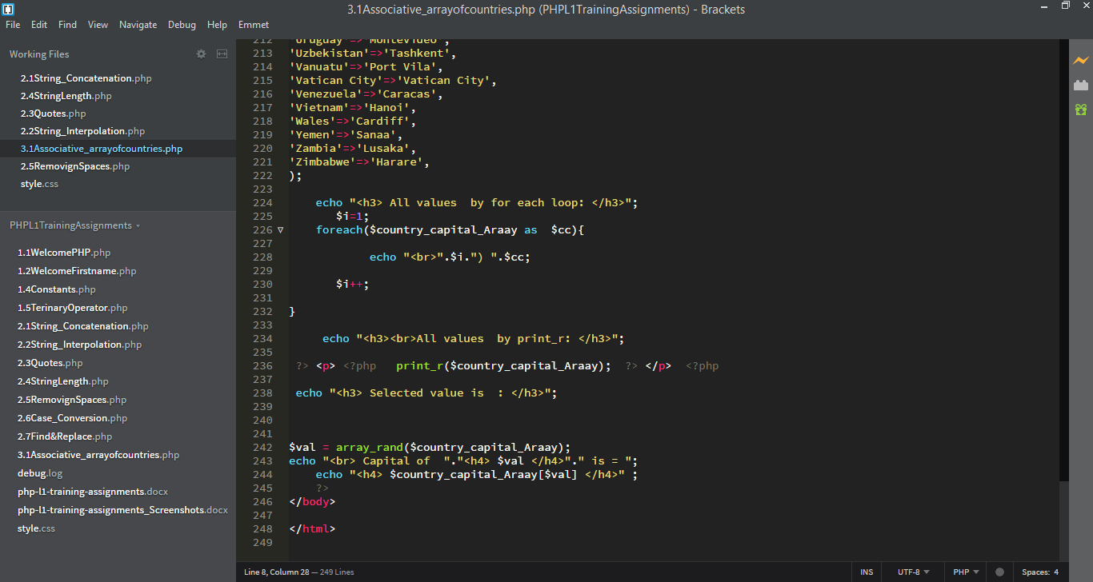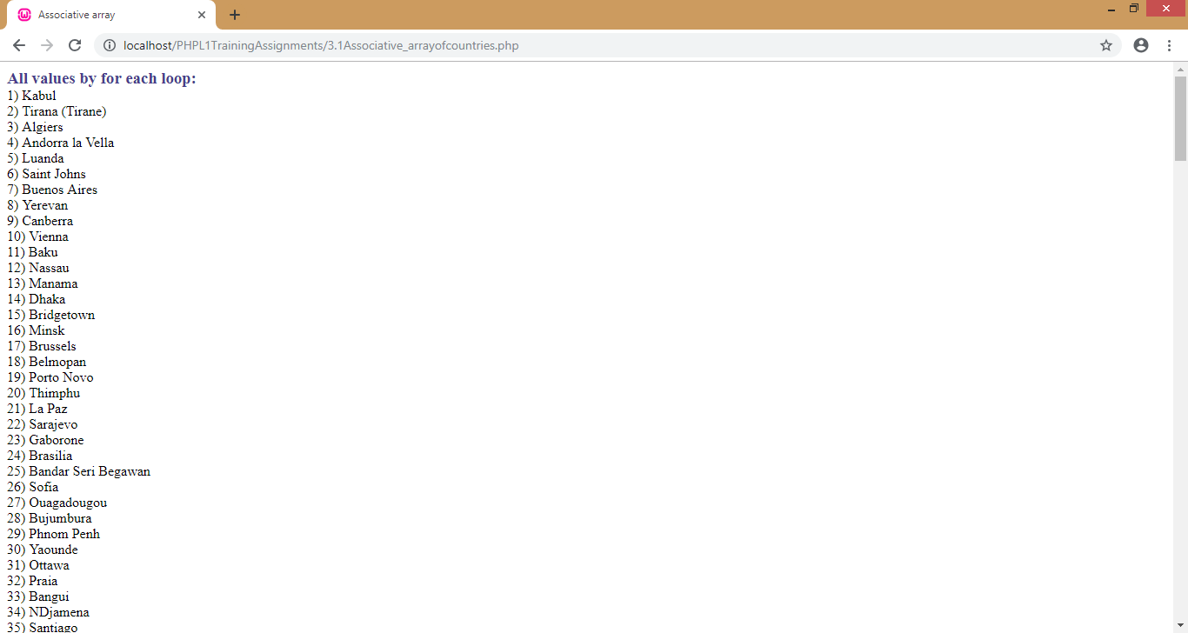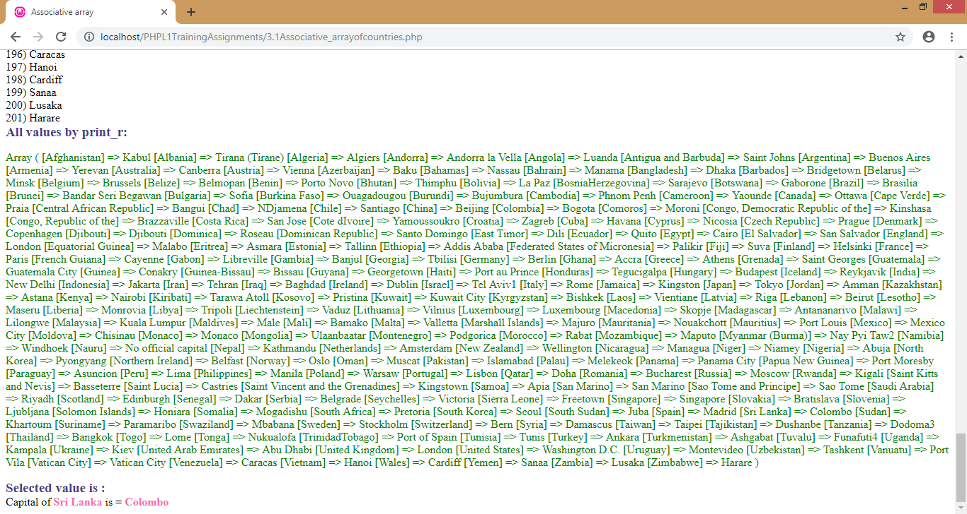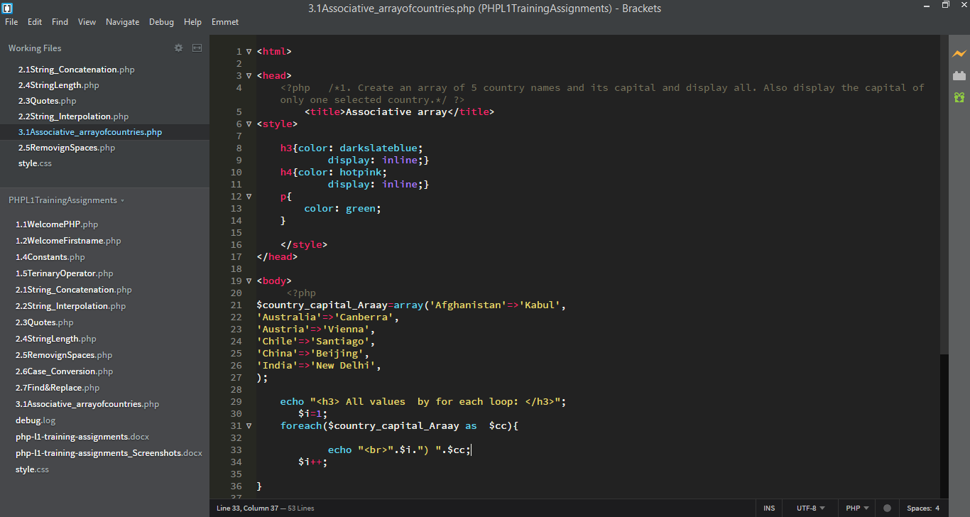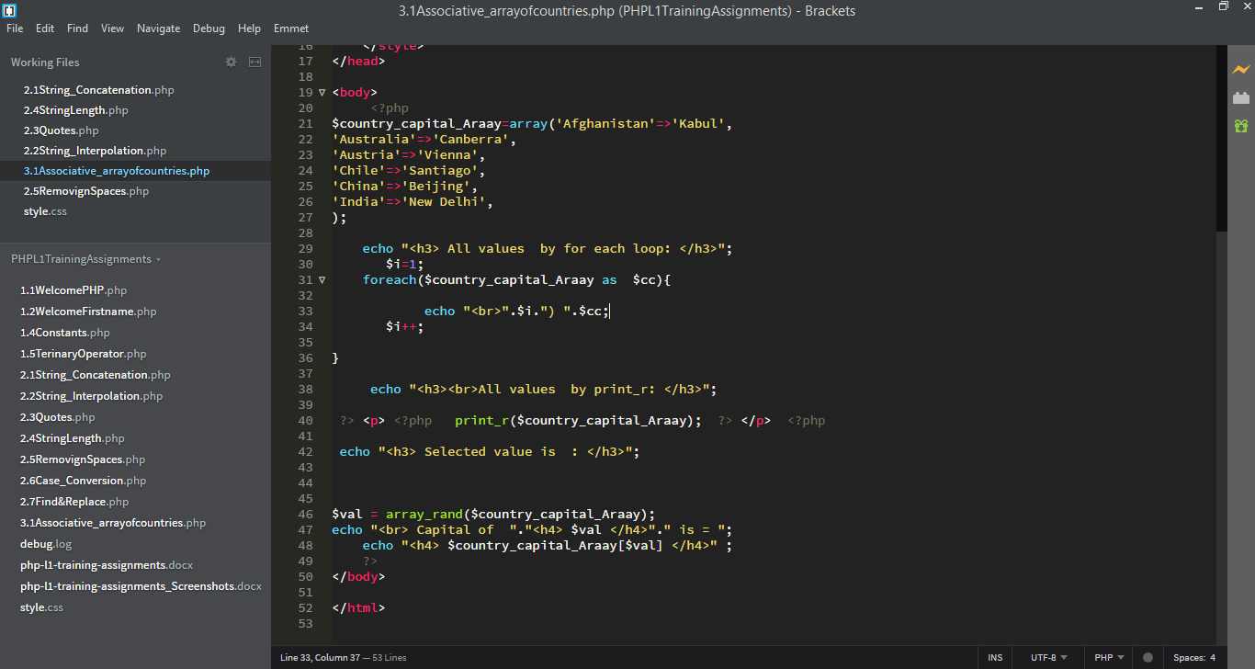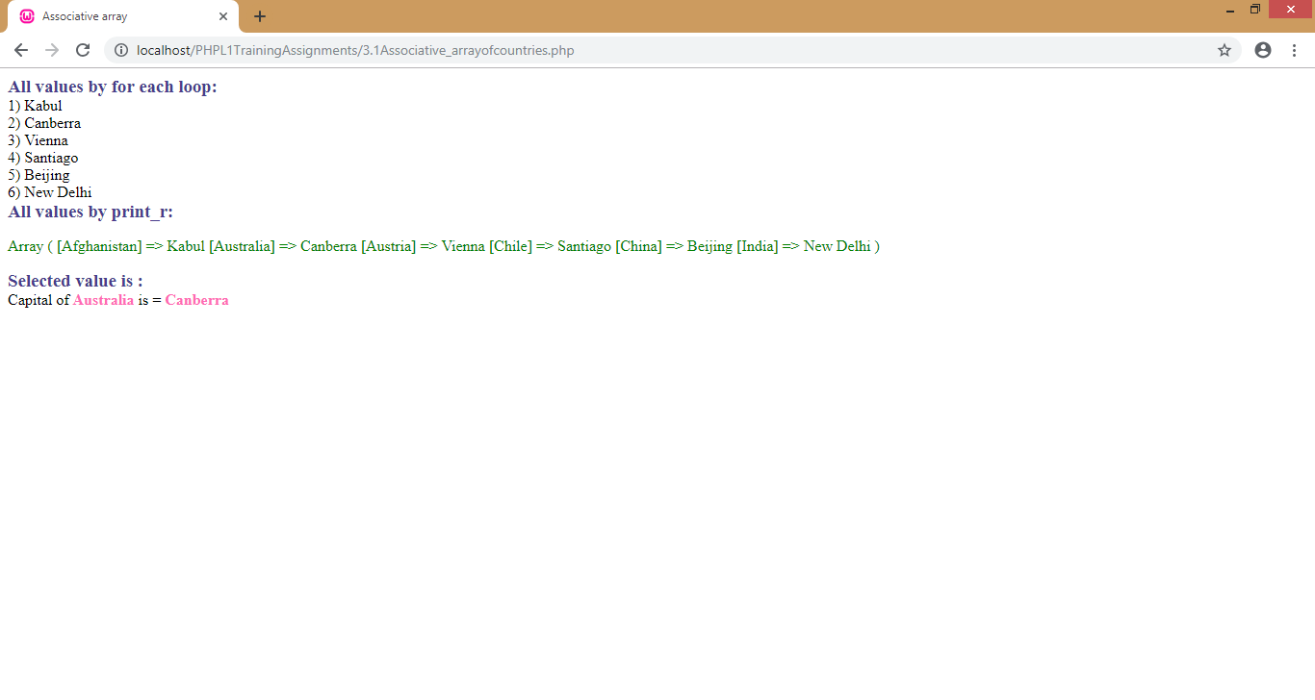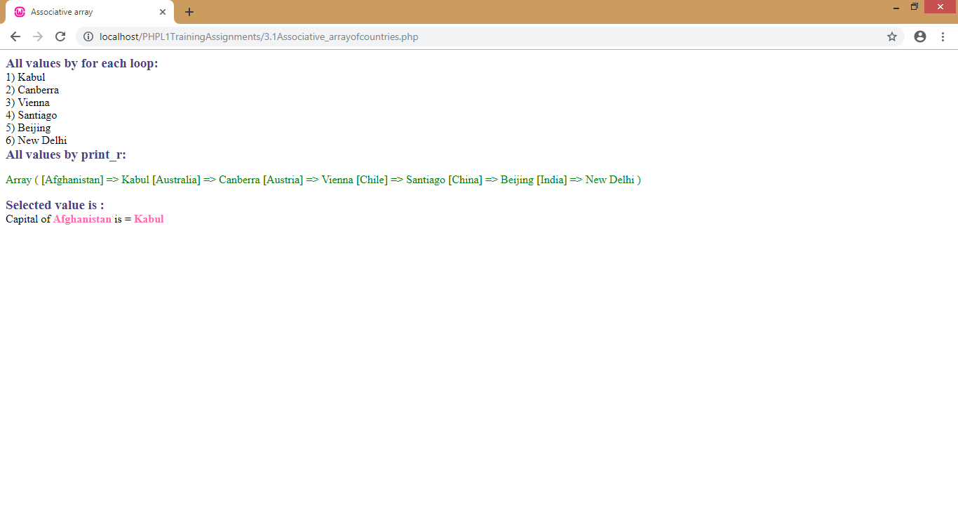2. Create a numeric array that contains the names of 10 students. Display the first and the last student names.

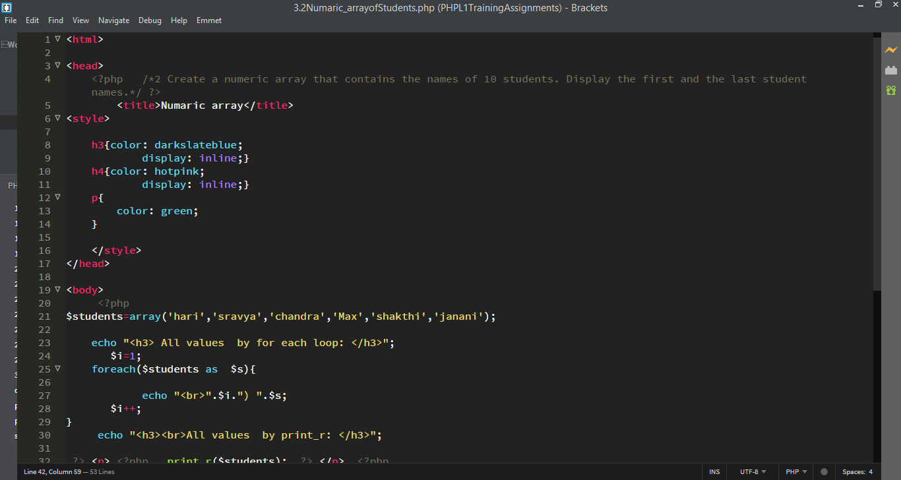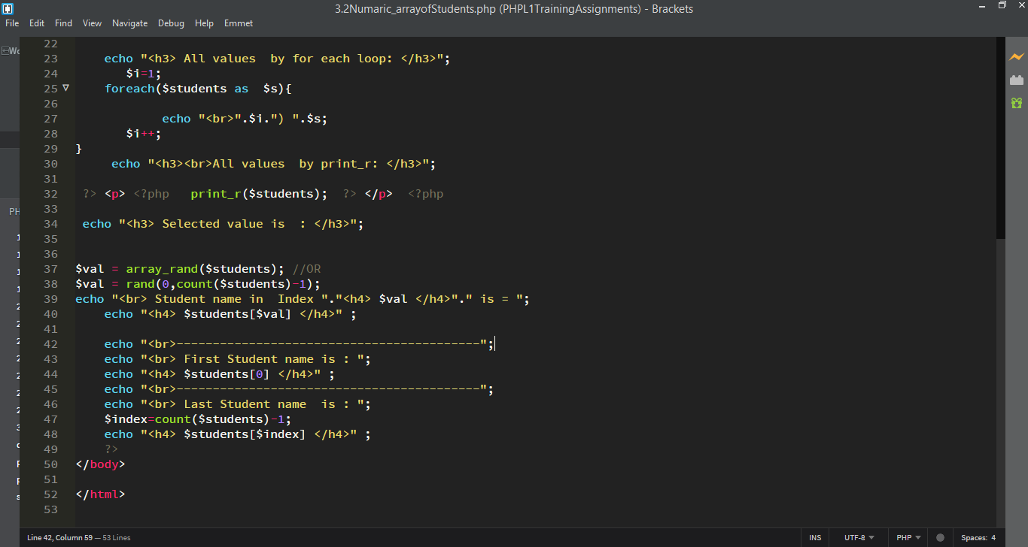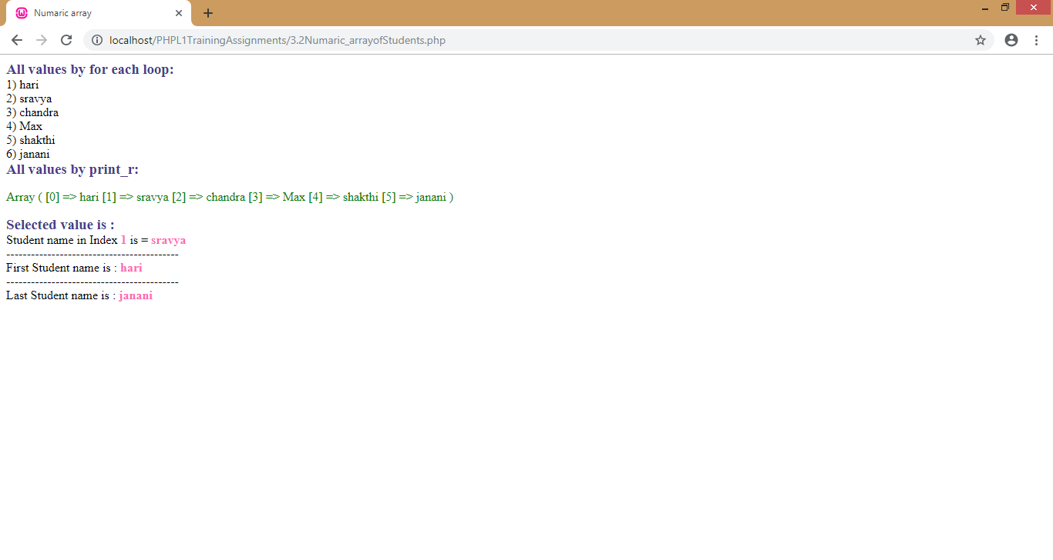3. Create a multidimensional array that contains the details like names of students and their respective class, phonenumber and marks of 5 students. Display the entire array. Also display the phone number of only one student.

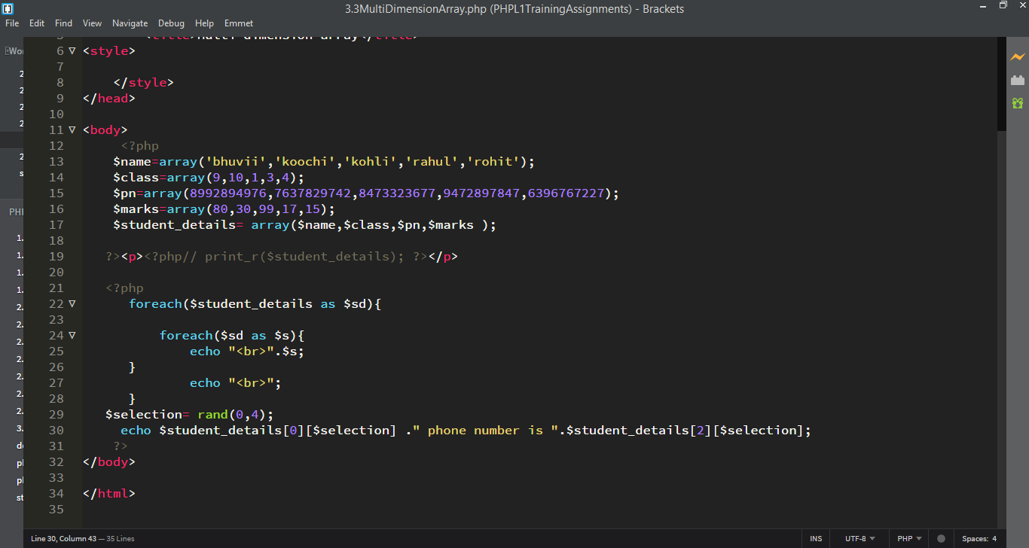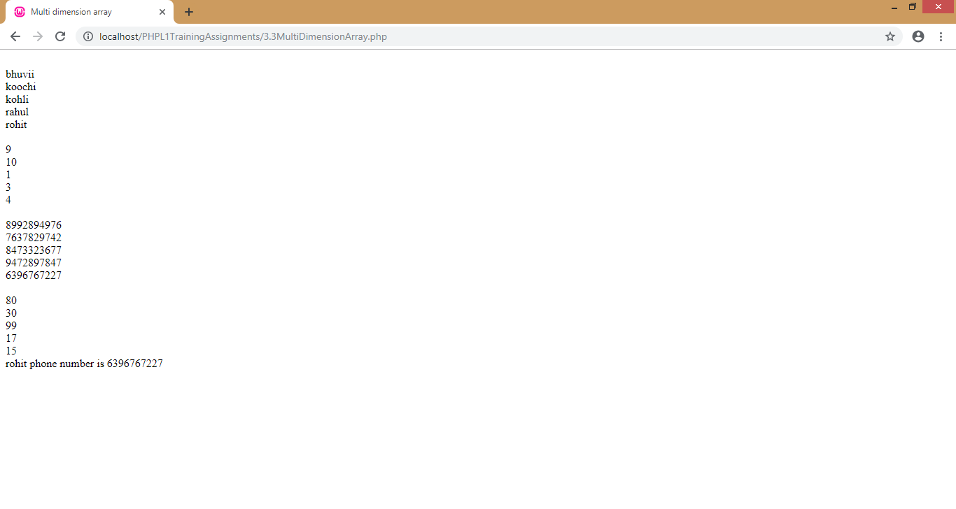4. An array contains the names of the top 10 highest mark achievers in a class. Remove and print the first element of the array. Count the items in the array now.

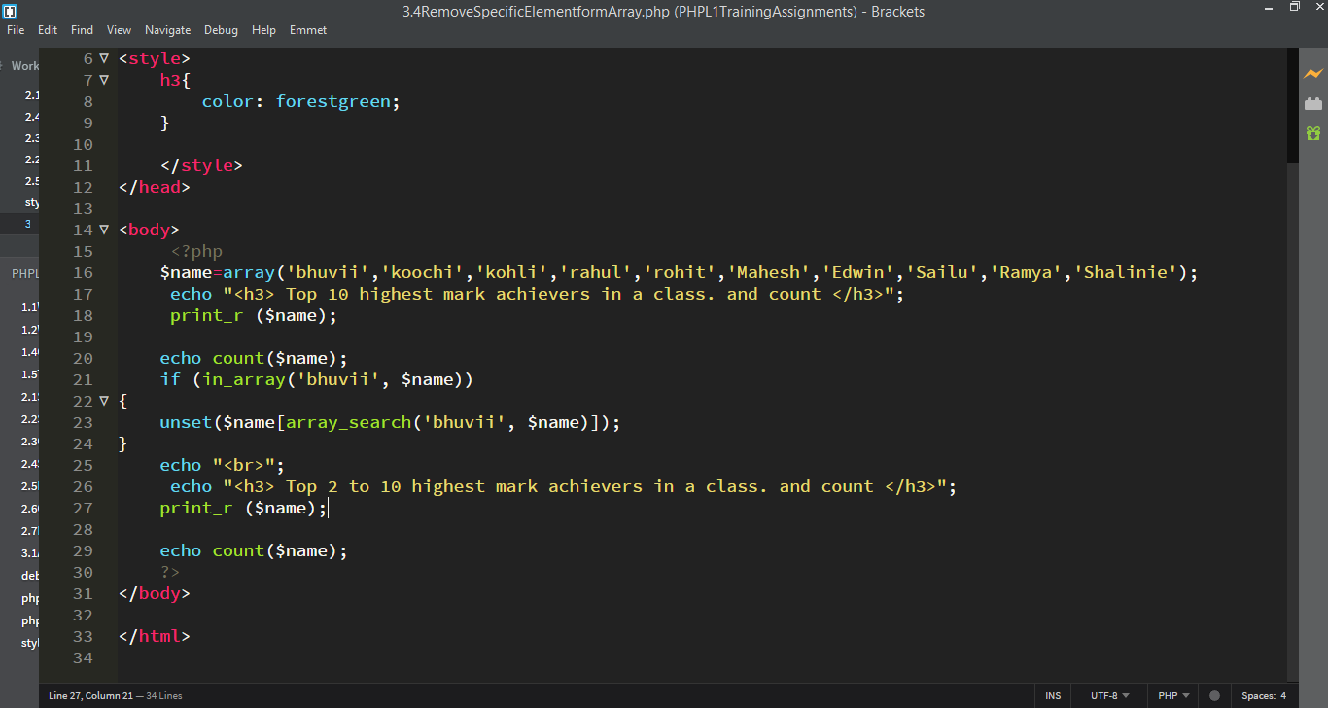

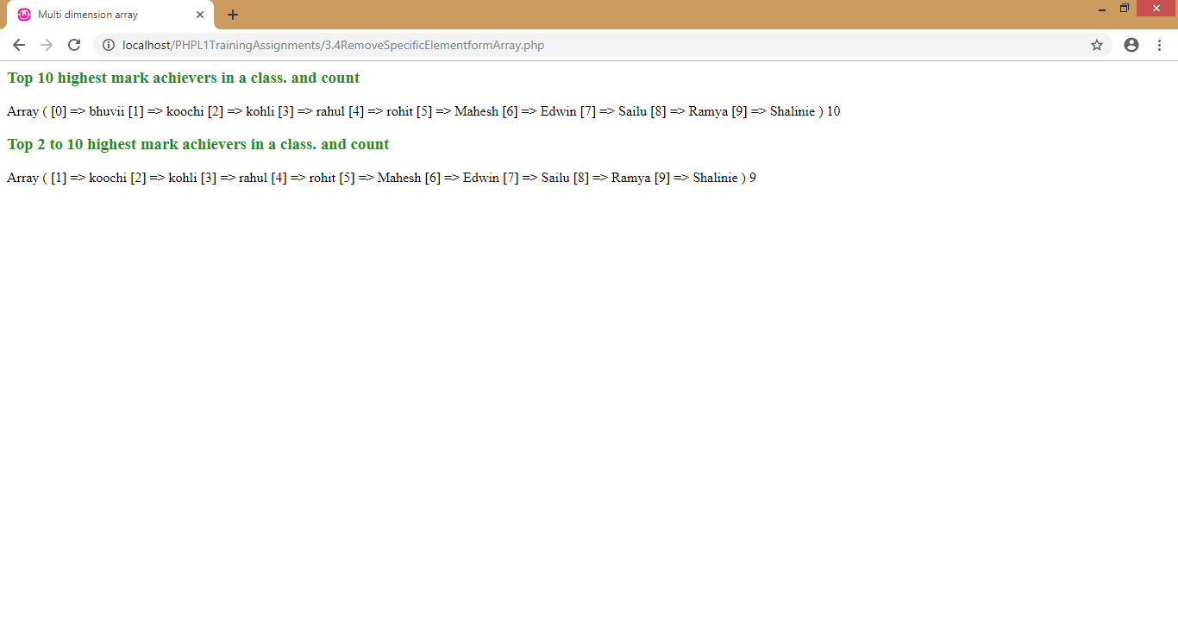**Module4: Branching and Looping Constructs**

1. A variable ‘marks’ contains the value 80. If marks is greater than 40, you need to display the message ‘Passed’ else ‘Failed’. 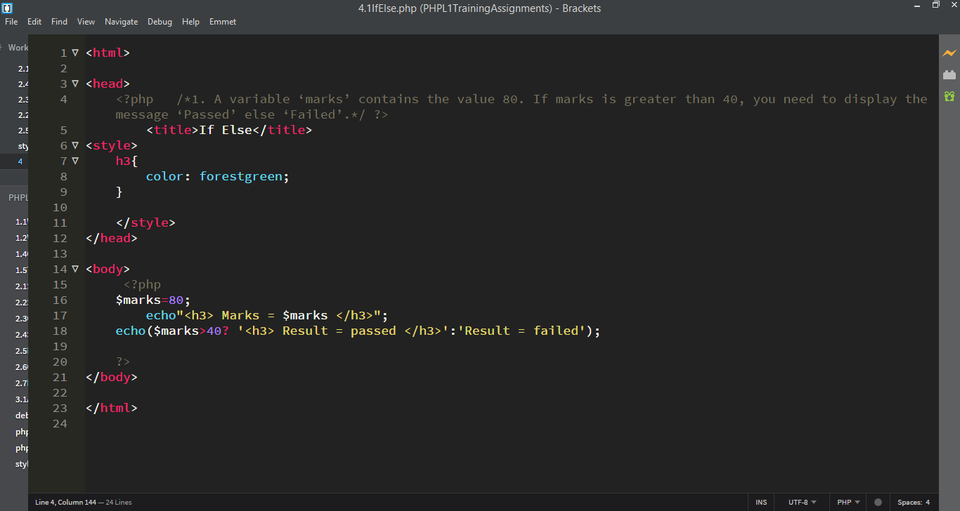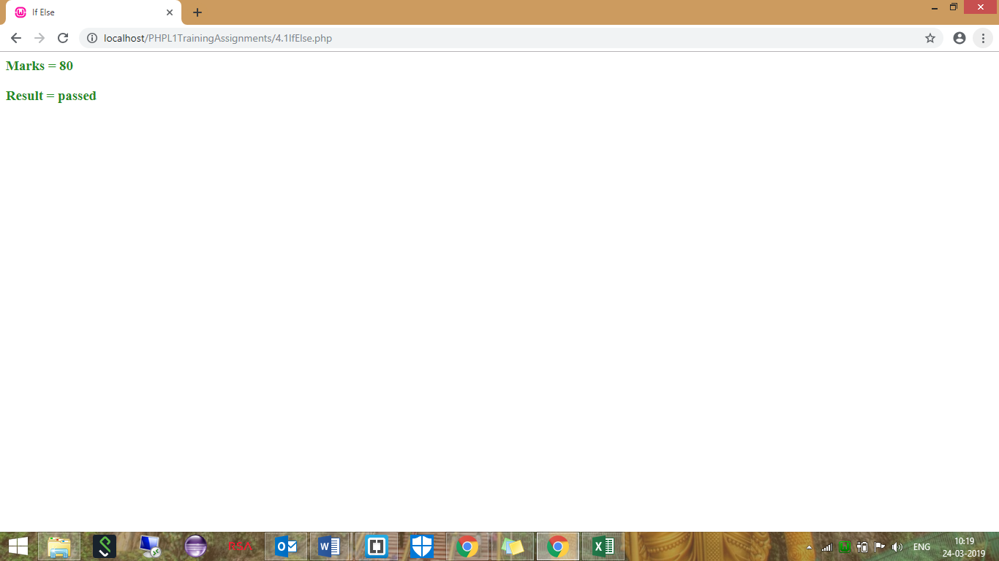2. A variable ‘appraisal’ contains the appraisal ratings for this year for the employees. If the rating is ‘OS’ display a message ‘15% hike’, if the rating is ‘ECC’ display a message ‘10% hike’, if the rating is ‘HVC’ display a message ‘5% hike’ and for all others display a message ‘Sorry No Hike’. 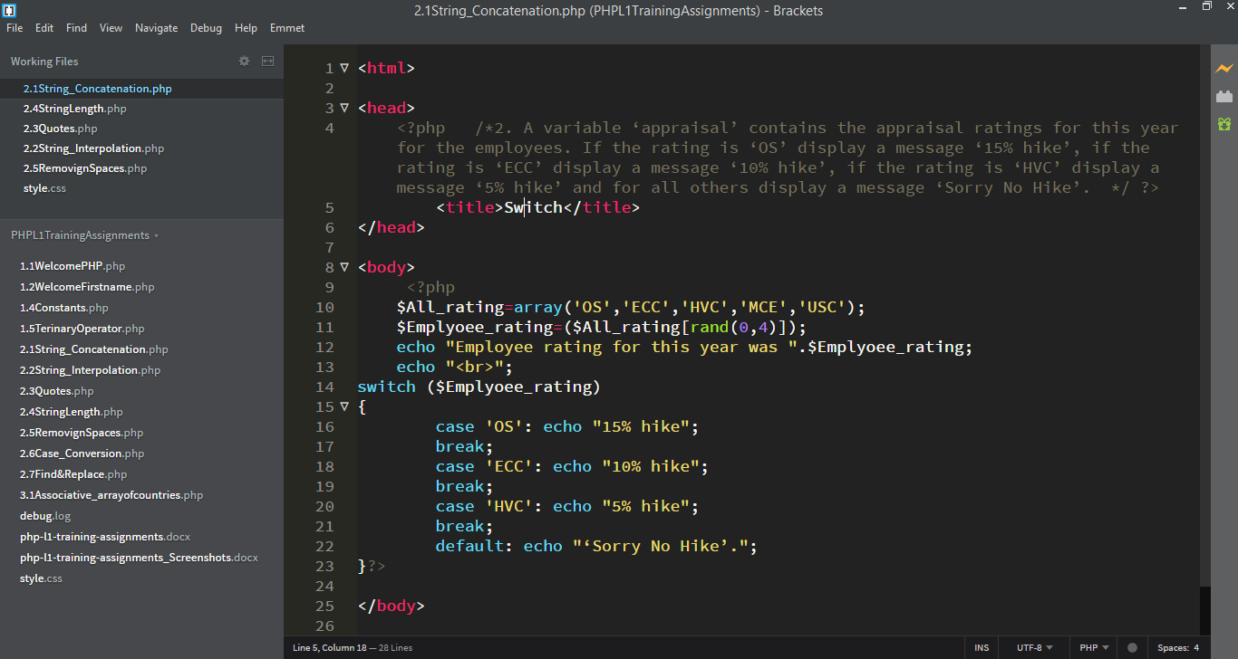

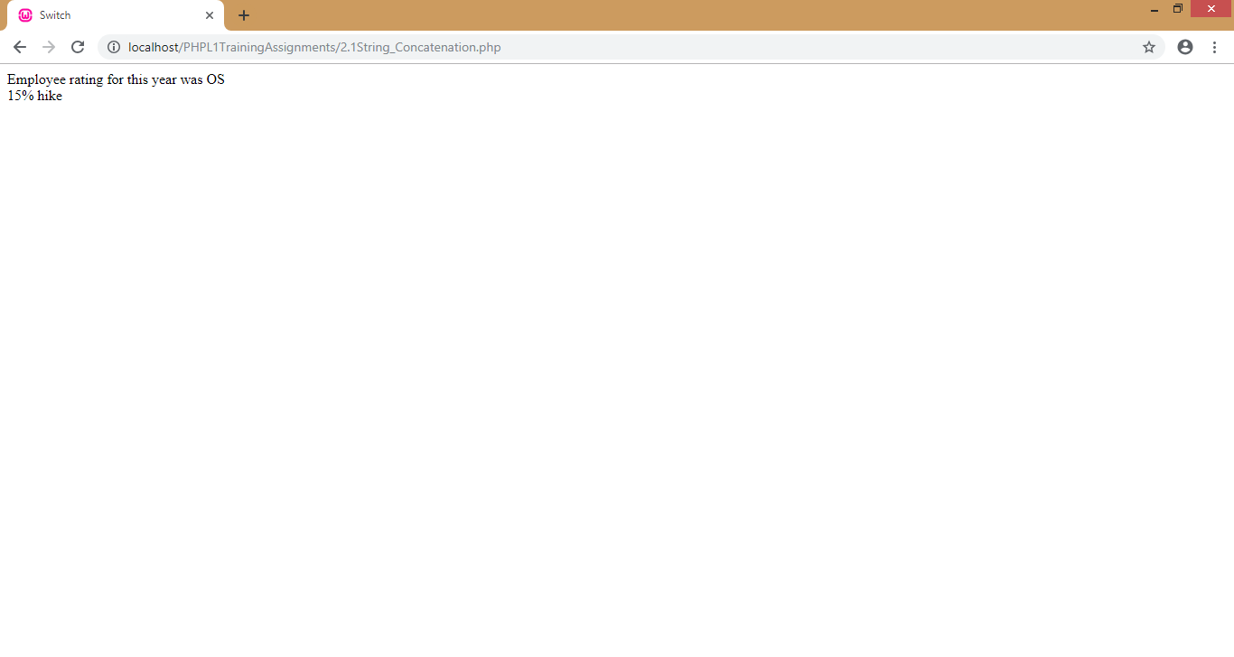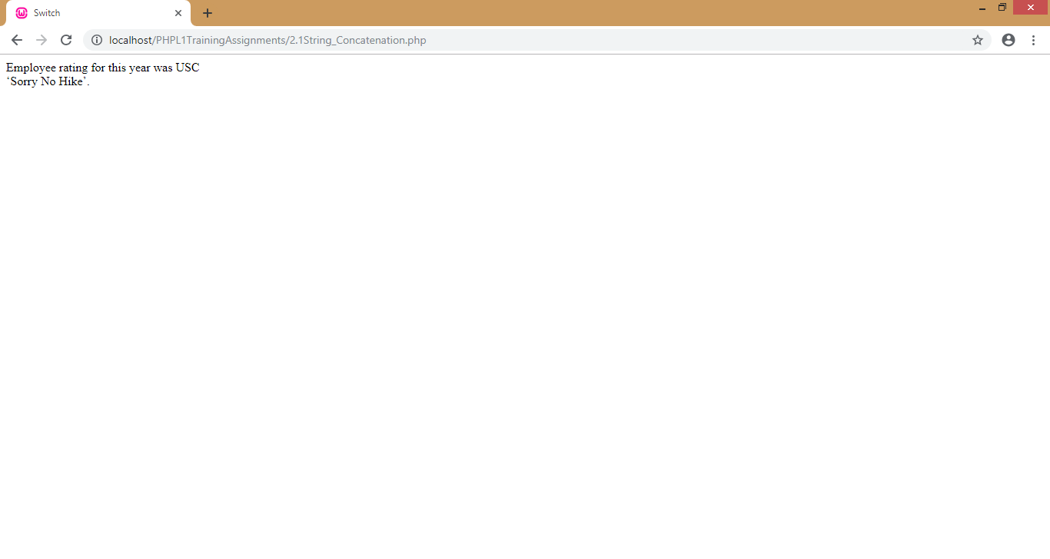3. Display all even values from 2-100 using ‘for’ loop and the ‘while’ loop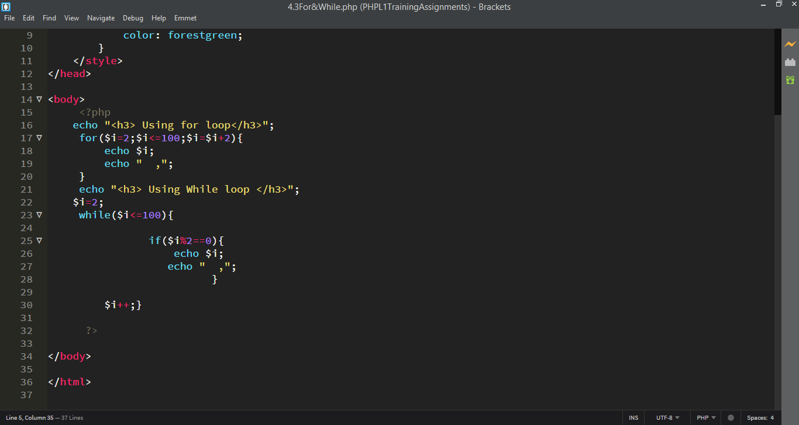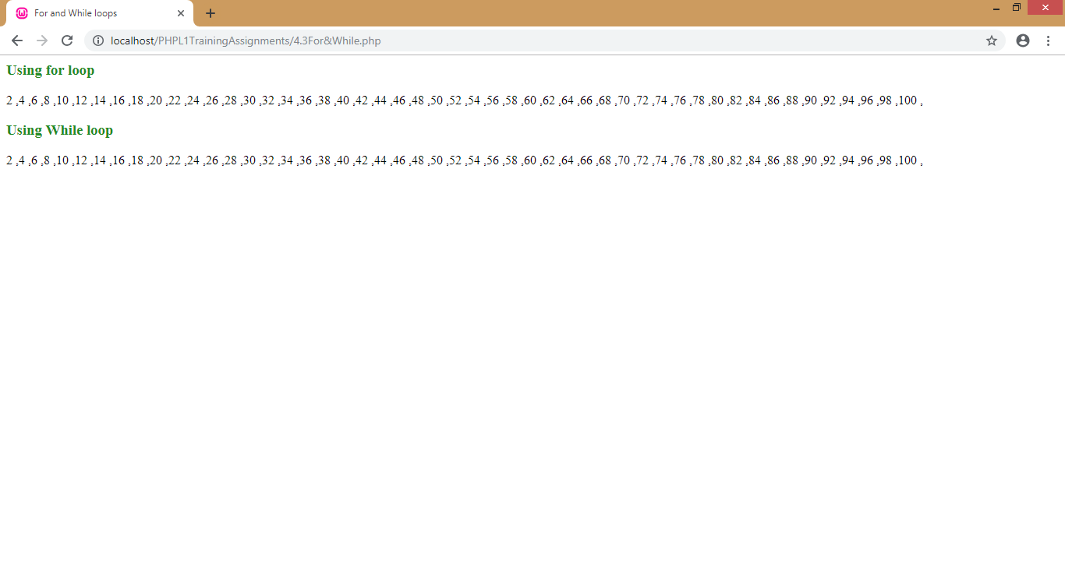4. The students marks is at present 34. Passing marks is 40. Write a PHP program which checks if the marks is between 32-39. If yes, keep giving 1 grace mark till the marks becomes 40. The max. marks after giving grace marks should not go beyond 40.

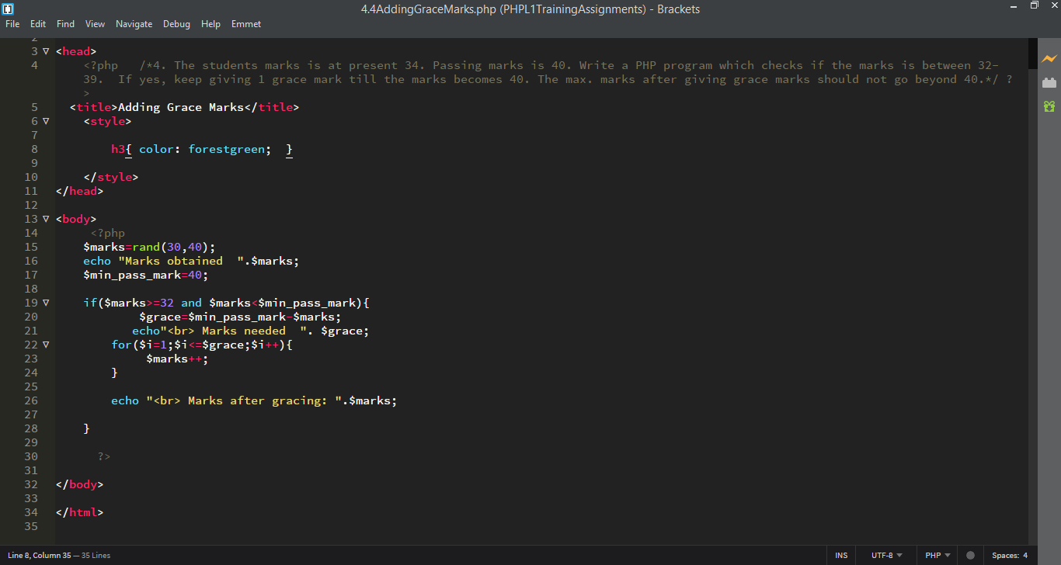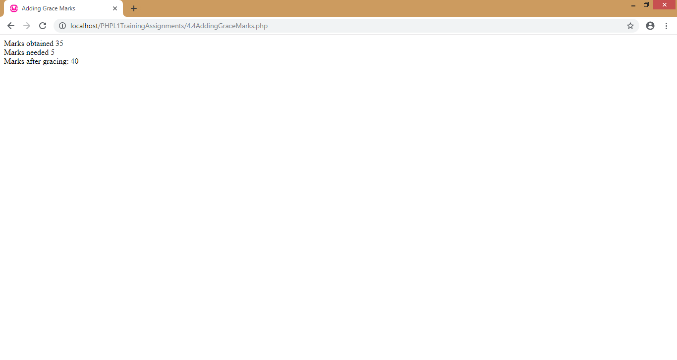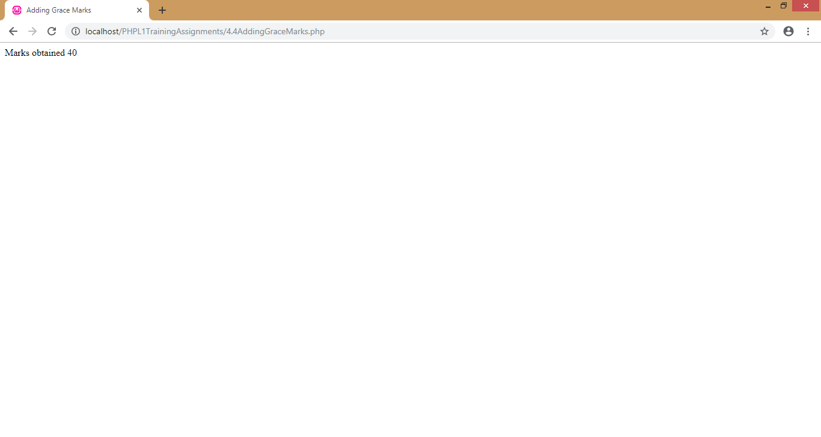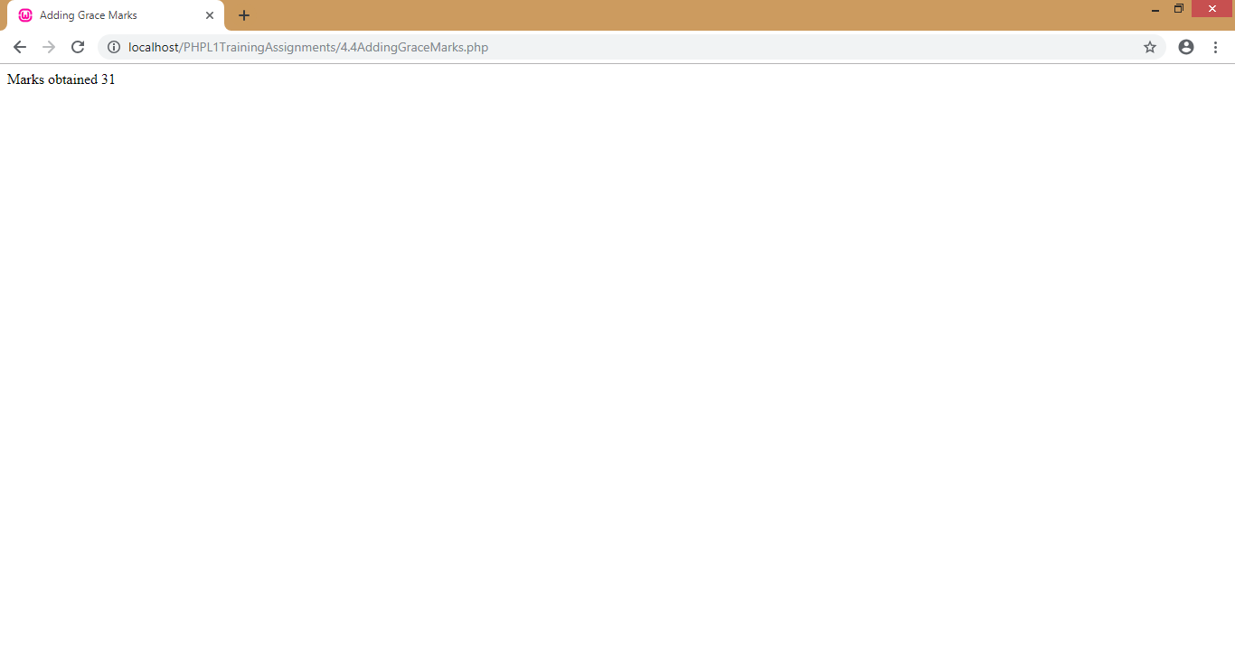**Module5: PHP Functions**

1. Write a PHP program using functions to generate multiplication tables in the below format.

|  |  |  |  |  |
| --- | --- | --- | --- | --- |
| 15 | X | 1 | = | 15 |
| 15 | X | 2 | = | 30 |
| 15 | X | 3 | = | 45 |
| 15 | X | 4 | = | 60 |
| 15 | X | 5 | = | 75 |
| 15 | X | 6 | = | 90 |
| 15 | X | 7 | = | 105 |
| 15 | X | 8 | = | 120 |
| 15 | X | 9 | = | 135 |
| 15 | X | 10 | = | 150 |

1. 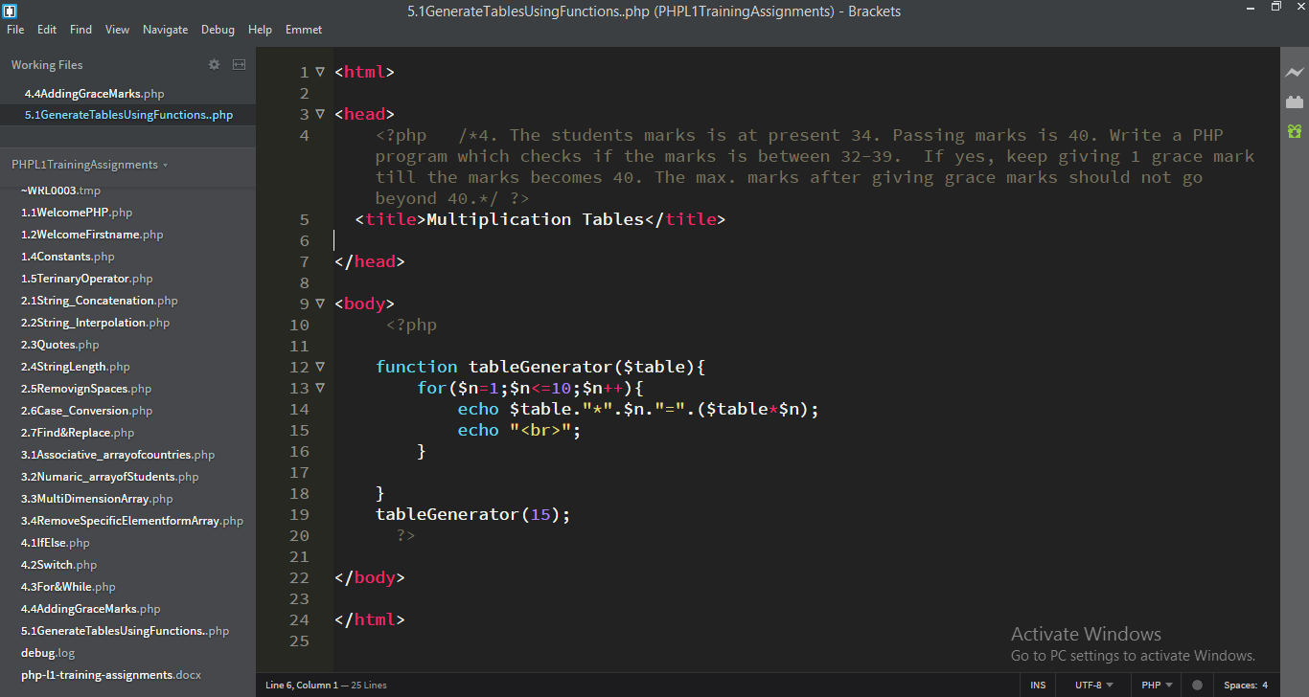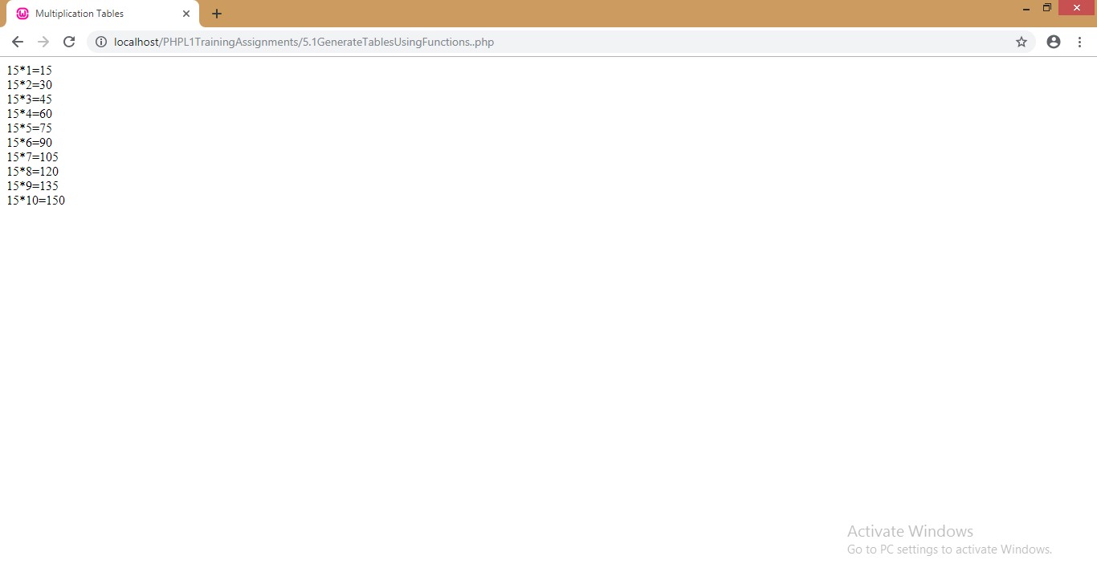Function should take a ‘number’ as one argument and ‘end number’ as second argument and generate the tables as above for the ‘number’ till the ‘end number’ (Here number is ‘15’ and the ‘end number’ is 10) (i.e. multiplication table of 15 from ‘15X1’ ‘15X10’)

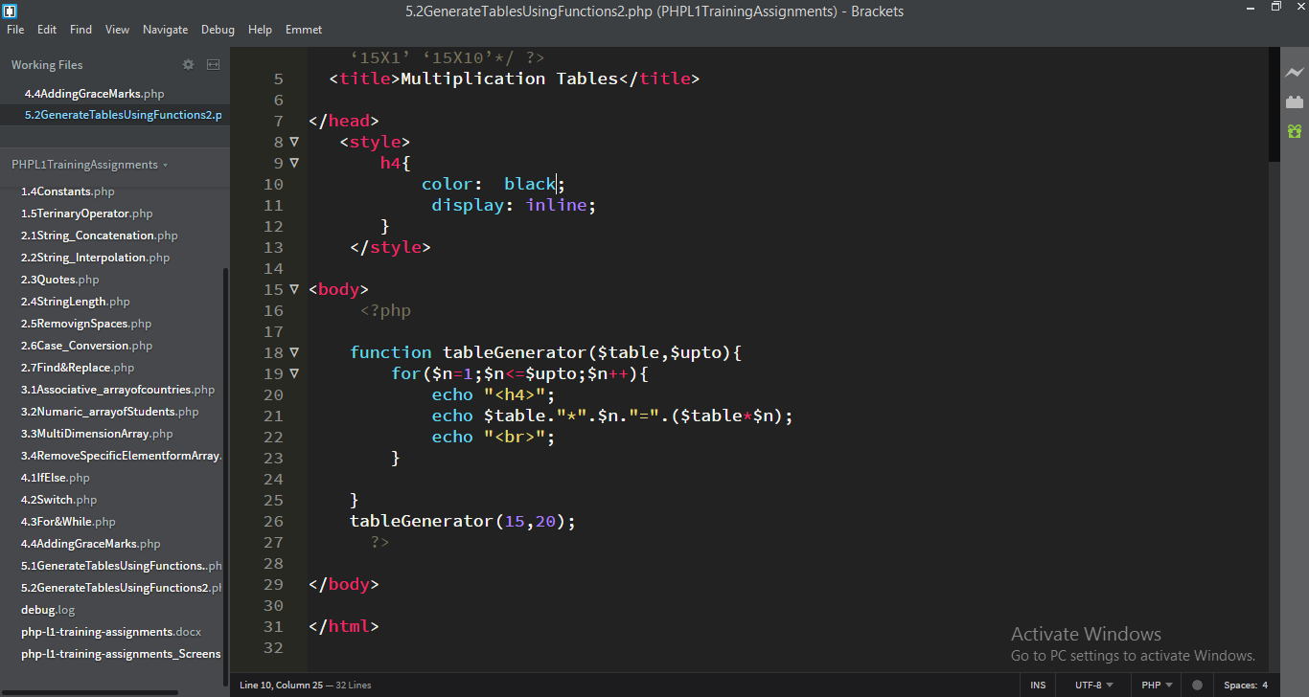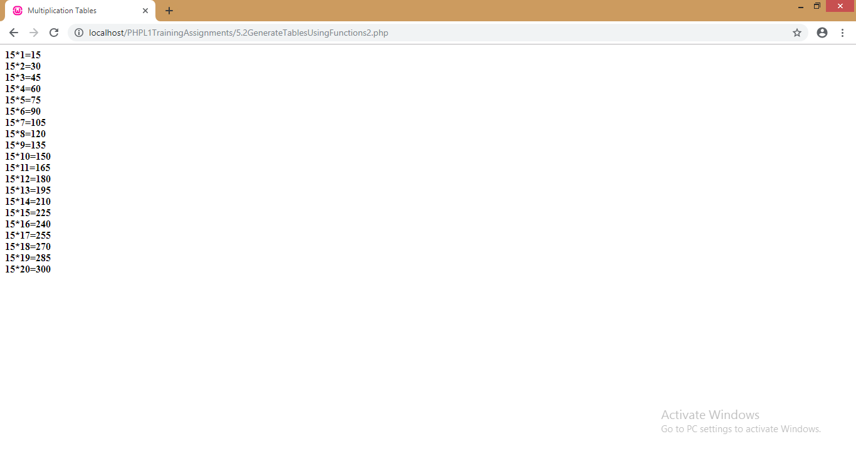**Module 6: PHP MySQL**

1. A table in MySQL called ‘Student’ has columns like ‘studentid’,’studentname’,’class’ and ‘marks’.

It has some sample records as well.

The PHP program should do the below:

* 1. Select all the records of the table as rows and display it.
  2. Update the marks of a particular student
  3. Delete the record of a particular student

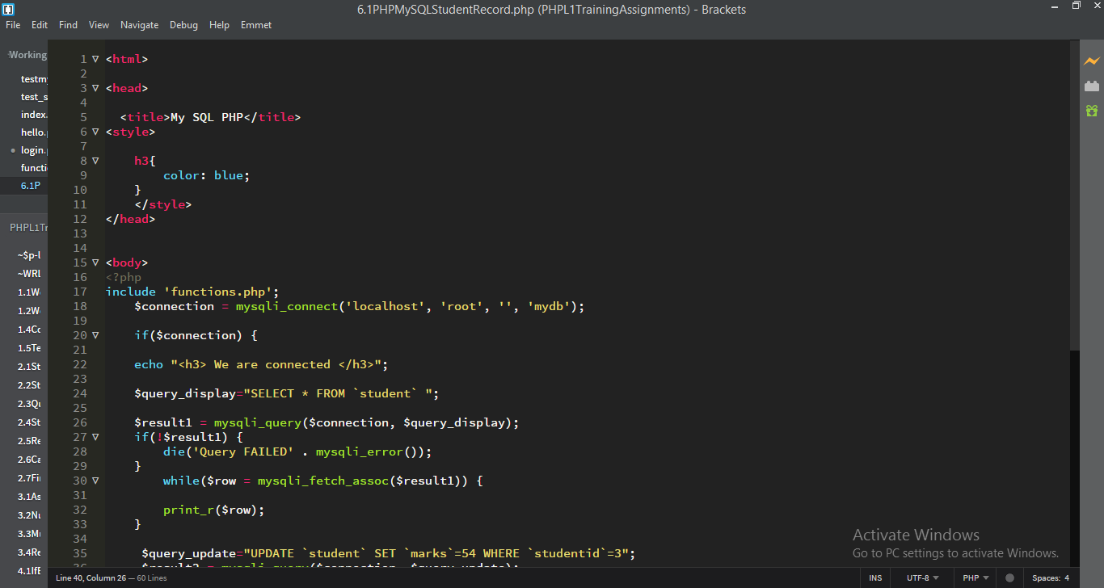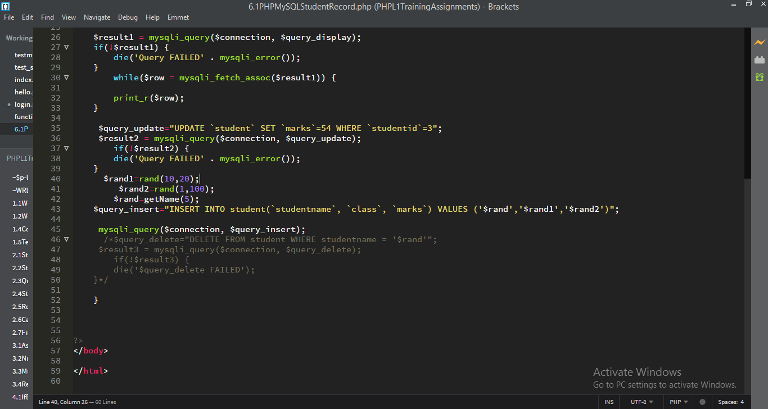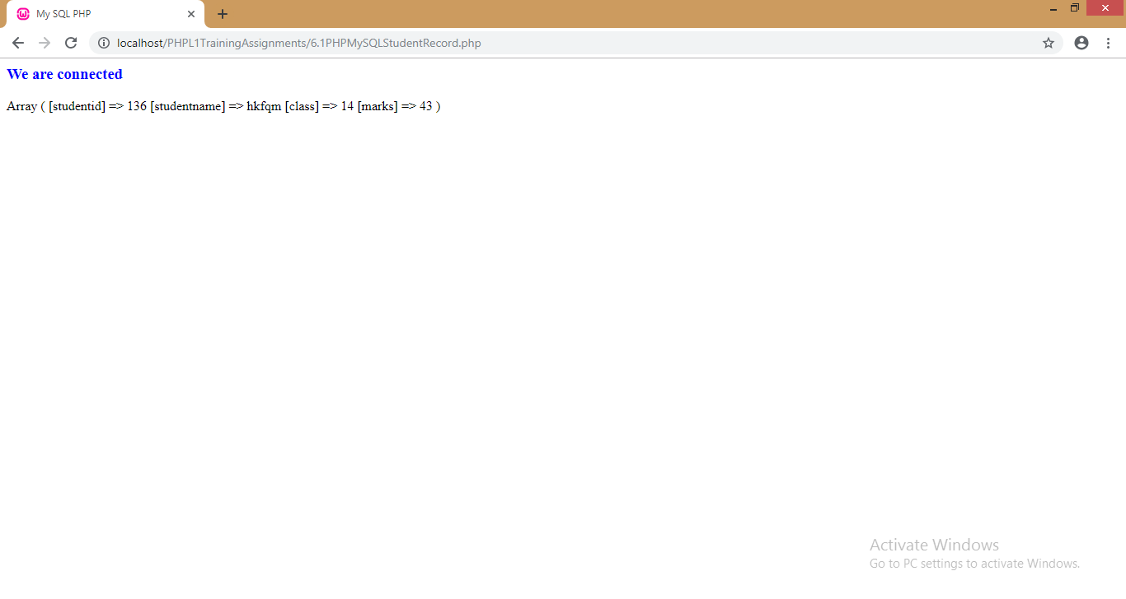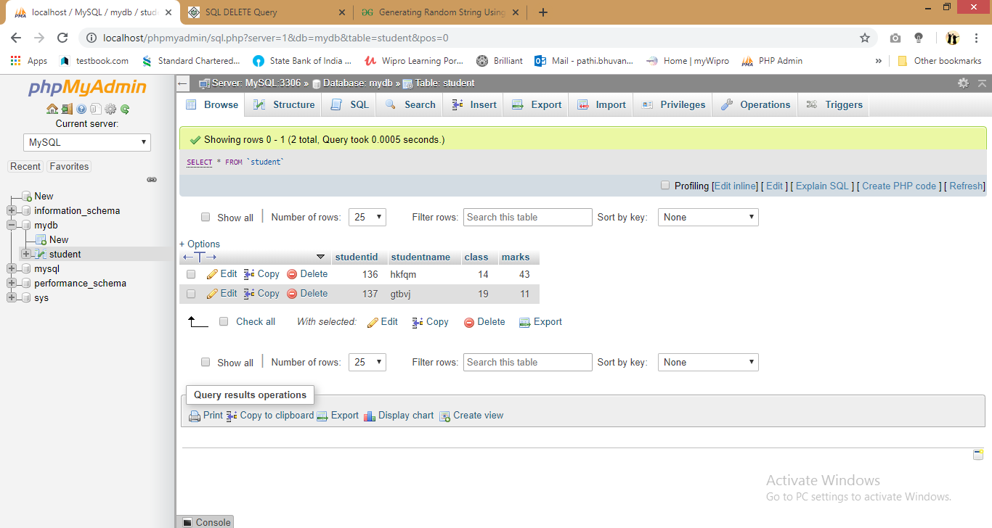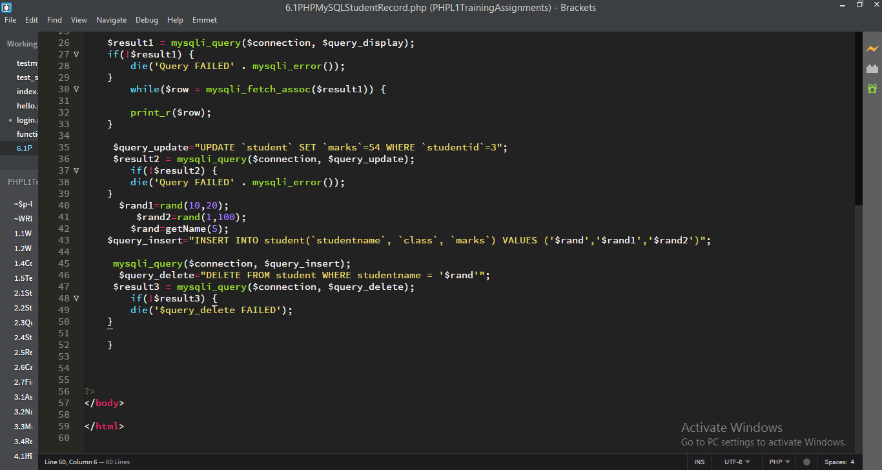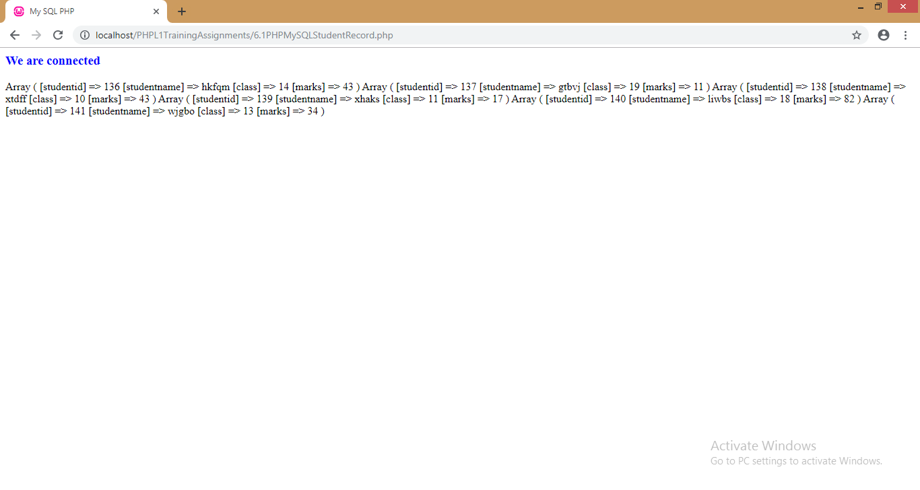

**Module7: PHP and HTML Forms**

1. Display a HTML form that contains two text boxes to enter ‘science’ and ‘maths’ marks and a submit button to the user. The user enters the marks and clicks on the submit button which in turn calls the PHP program that displays the ‘Total Marks’ of the user and also the ‘Average Marks’ of the user by performing appropriate calculations.

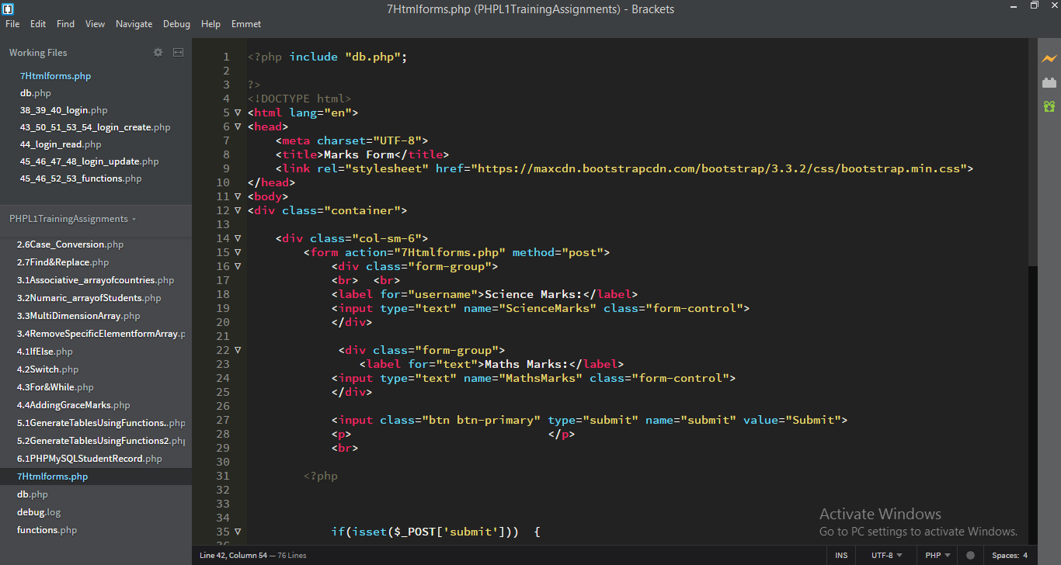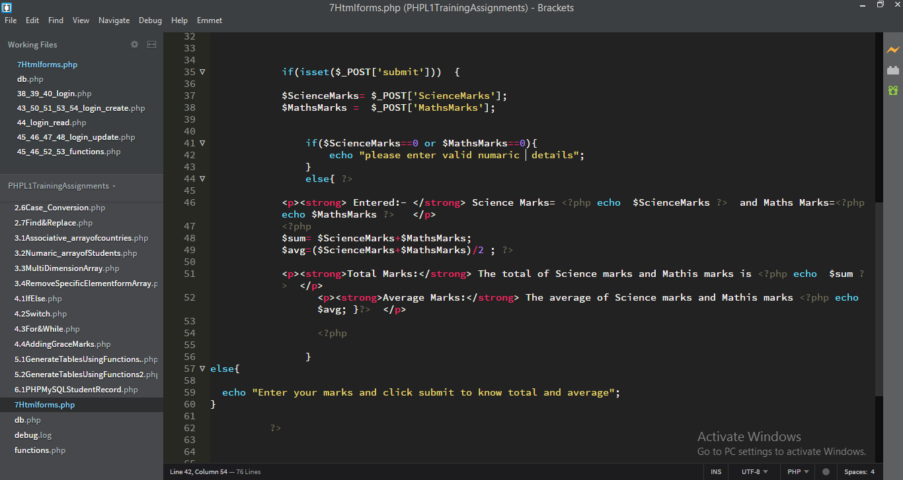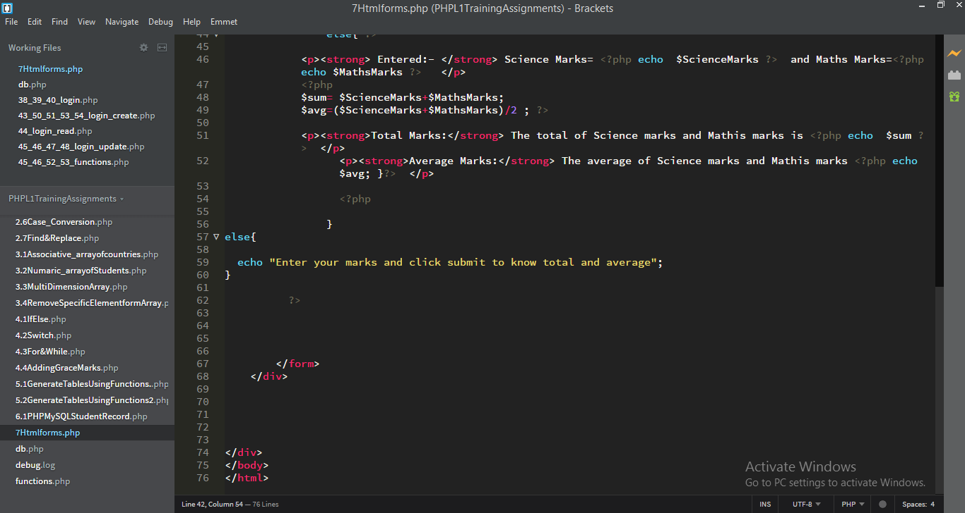

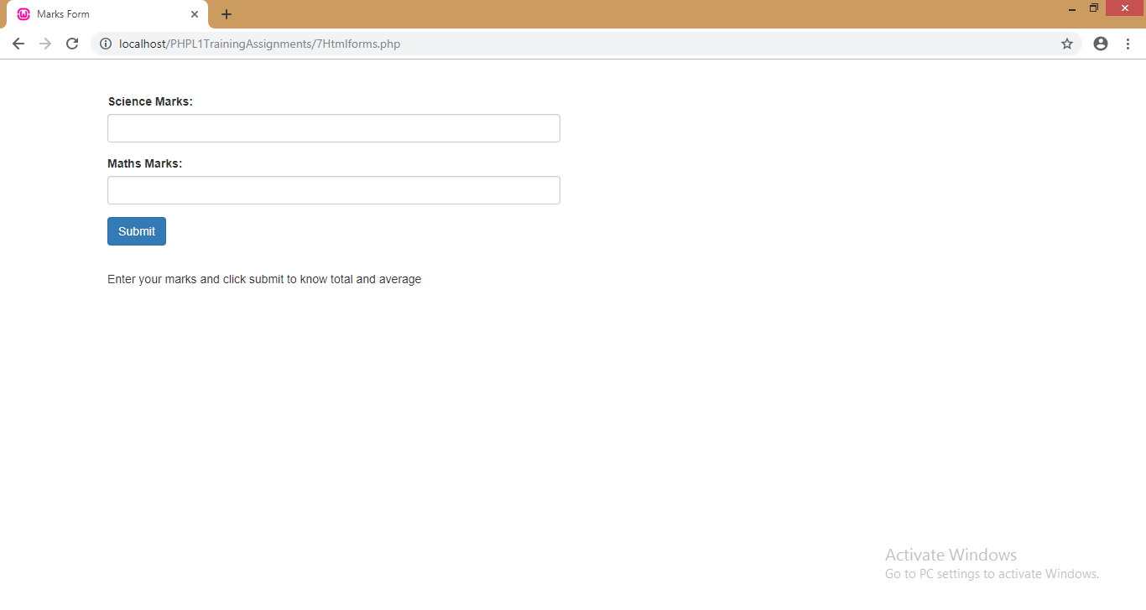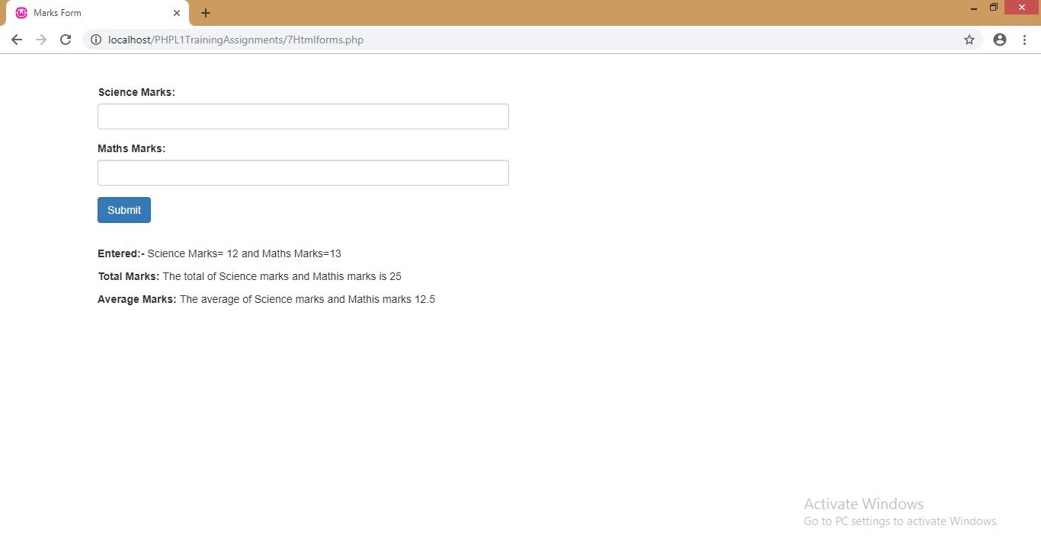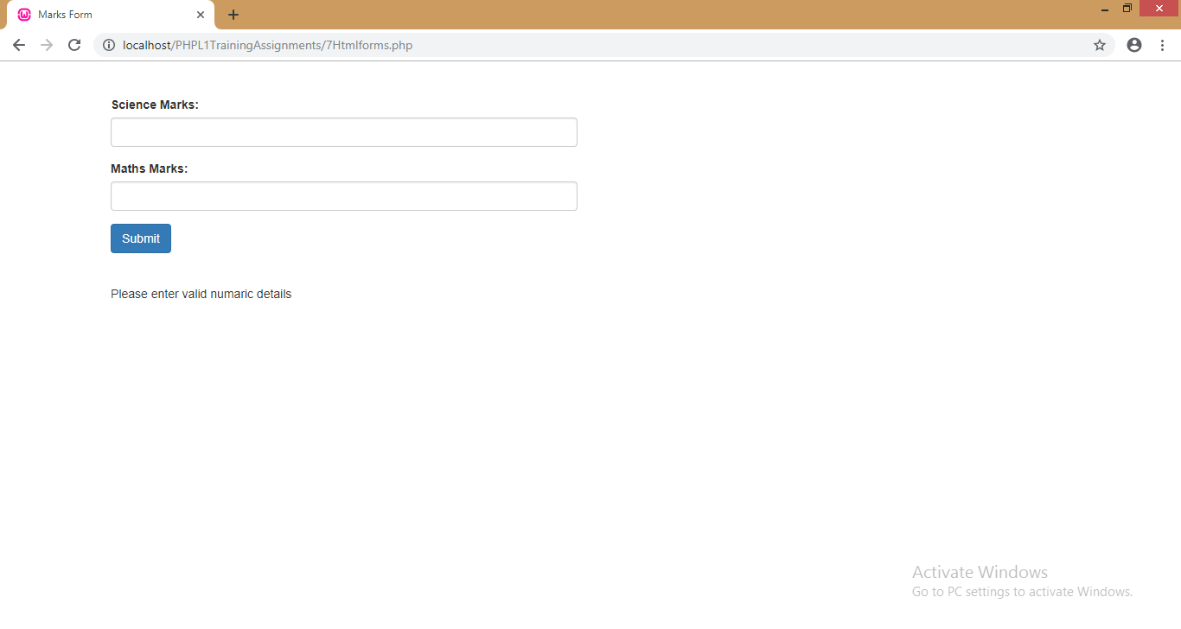**Module8: PHP Regular Expressions**

1. Write a program to find whether the pattern ‘ball’ exists in a string. If yes, display the matched items.

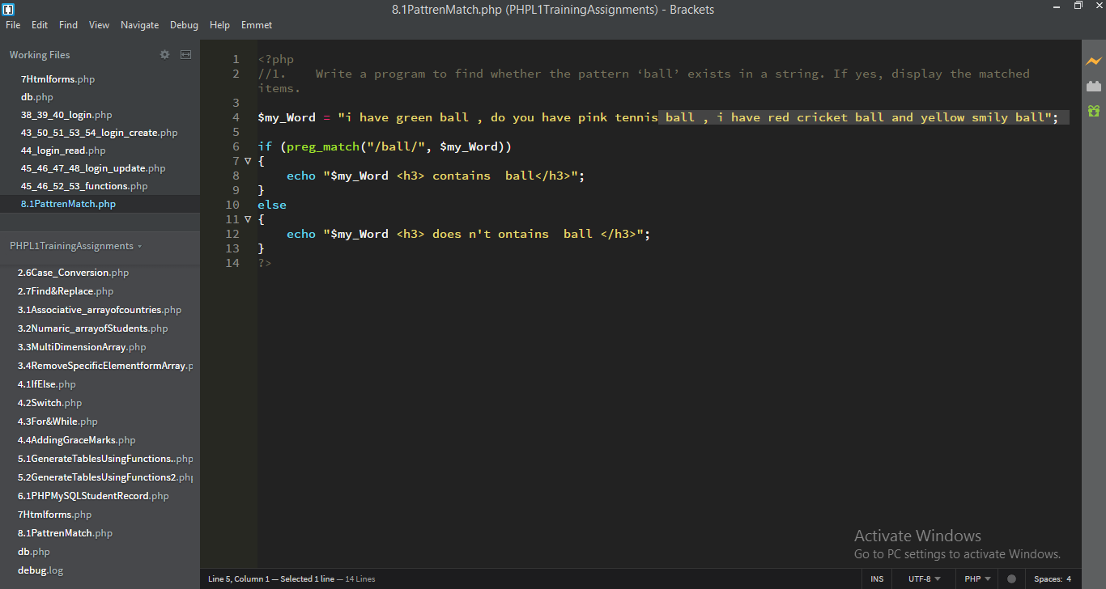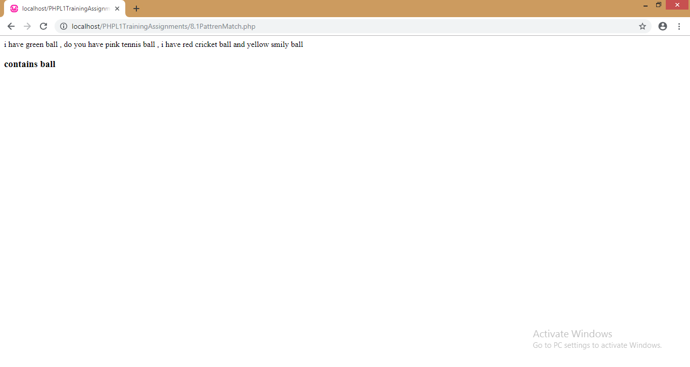

Write a program to check whether the string contains a pattern with 3 numbers only (not less not more) If yes, display that number.

